Tsunami Notes:

What is a Tsunami?

Tsunami –

Quick Notes:
- Also called __________________________, even though it has no relationship to tides
- Tsunami is Japanese; “tsu” = harbor, “name” = wave

How Do the Form?

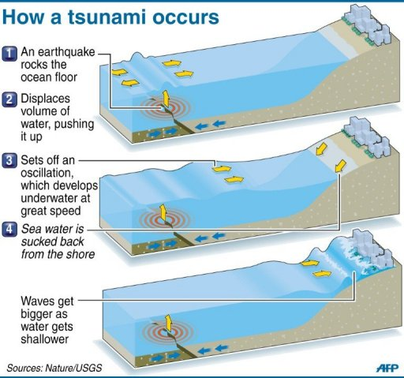
Accepted Theory of Formation –

Process:
- Noticeable displacement of the ocean crust due to ___________________________

- As a result there is a sudden upheaval of the ______________________
- The ocean surface mirrors a similar upheaval
- As the ocean surface returns to normal level, it creates a:______________________________

Transform and Land Based Faults:

Major Tsunamis:
Caused by earthquakes of _________________________, with a shallow origin

At Sea:

Not perceptible from ships or planes as they are usually less than __________________ high and often more than 160 km long.

“Feel the Bottom” –

Capable of speeds up to ___________________________________________ in the deepest of water.

At Coastline:

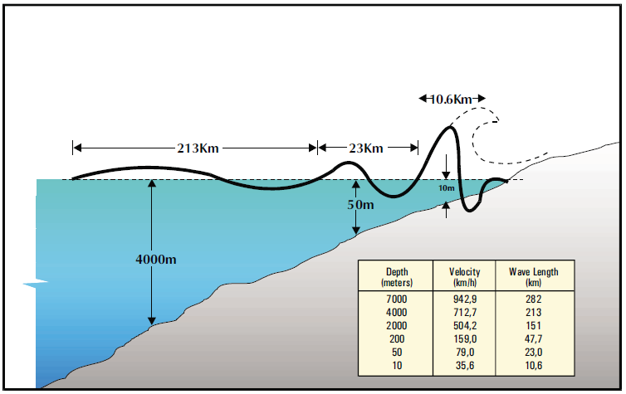
As depth begins to decrease:
- Wave speed ____________________________________________ (more so on the bottom, thus waves can catch up with each other)

- Wave length ____________________________________(as waves catch up to the ones in front)
- Wave heights _________________________________

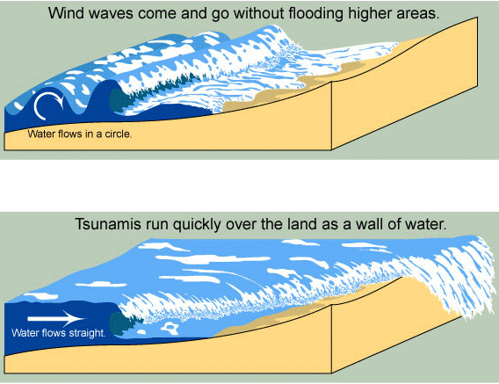
Before the tsunami hits, there is a gradual recession of coastal water due to the arrival of the trough preceding the first crest or a rise in water up to ½ the amplitude of the recession that will follow it.

Tsunami’s can be modified in characteristics as they approach the coastline by offshore or coastal structures. These can include (plus many more):

Wave heights can reach up to ______________________________________ or more in height

Coastal Variations:
- The funneling effect of a bay may ______________________ the wave height

- An offshore sandbar may __________________________ the height
- Thus the same tsunami may have drastically different effects on a single coastline

Tsunami Detection and Warning:

___________________________________________ (TWS) – objective is to detect and locate major earthquakes in the Pacific Region, to determine whether they have generated tsunamis, and to provide timely warnings

Process:
- All seismic activity is sent to the TWS
- Tidal stations monitor for evidence of a tsunami
- Any earthquake at 7.5 or greater results in the issuing of a Tsunami Warning/Watch Bulletin
- If evidence shows there is a tsunami and it poses a risk for part of the Pacific, the Bulletin is extended to the whole Pacific

