Tsunami Notes:

What is a Tsunami?

Tsunami – a large destructive wave that is the result of a geologic process such as an earthquake (most likely), volcano, or land slide (both far less frequently)

Quick Notes:
- Also called tidal waves, even though it has no relationship to tides
- Tsunami is Japanese; “tsu” = harbor, “name” = wave

How Do the Form?

Accepted Theory of Formation – Tsunami’s are generated by a sudden, vertical motion along faults during Earthquakes

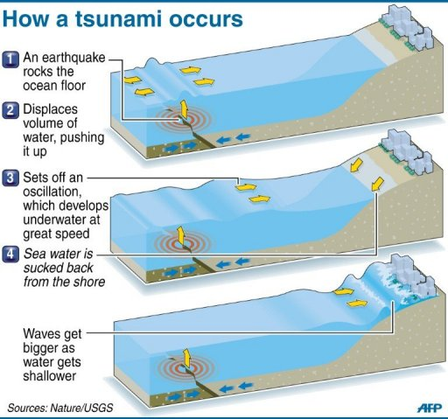
Process:
- Noticeable displacement of the ocean crust due to earthquake
- As a result there is a sudden upheaval of the ocean floor
- The ocean surface mirrors a similar upheaval
- As the ocean surface returns to normal level, it creates a series of waves in all directions

Transform and Land Based Faults:
Can be formed by transform boundaries, though typically very weak. Can also be formed by in-land earthquakes, denoting the possibility they can be created by seismic waves instead of crustal movements

Major Tsunamis:
Caused by earthquakes of 7.0 or higher, with a shallow origin

At Sea:

Not perceptible from ships or planes as they are usually less than 60 cm high and often more than 160 km long.

“Feel the Bottom” – the energy moving through the water goes from the ocean surface to ocean floor

Capable of speeds up to 900 km/hour (558 miles per hour) in the deepest of water.

At Coastline:

As depth begins to decrease:
- Wave speed decreases (more so on the bottom, thus waves can catch up with each other)
- Wave length decreases (as waves catch up to the ones in front)
- Wave heights increase

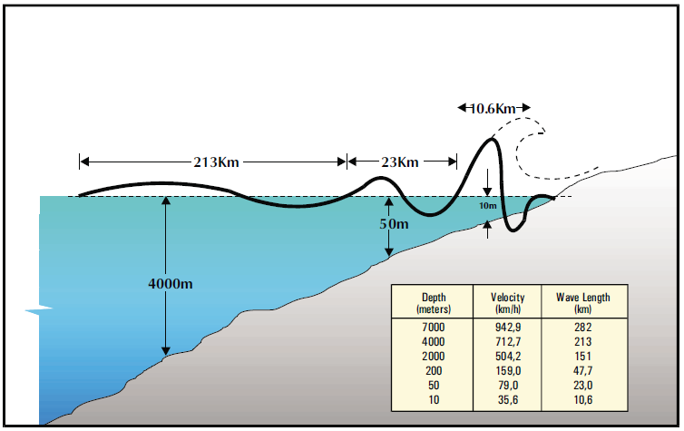

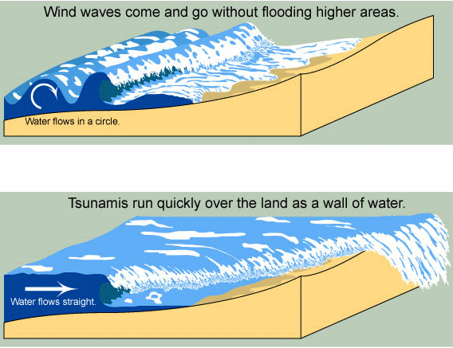
Before the tsunami hits, there is a gradual recession of coastal water due to the arrival of the trough preceding the first crest or a rise in water up to ½ the amplitude of the recession that will follow it.

Tsunami’s can be modified in characteristics as they approach the coastline by offshore or coastal structures. These can include (plus many more):
- The continental shelf
- Submerged reefs
- The shapes of bays
- Steepness of the beach slope

Wave heights can reach up to 30 meters or more in height

Coastal Variations:
- The funneling effect of a bay may increase the wave height
- An offshore sandbar may decrease the height
- Thus the same tsunami may have drastically different effects on a single coastline

Tsunami Detection and Warning:

Tsunami Warning System (TWS) – objective is to detect and locate major earthquakes in the Pacific Region, to determine whether they have generated tsunamis, and to provide timely warnings

Process:
- All seismic activity is sent to the TWS
- Tidal stations monitor for evidence of a tsunami
- Any earthquake at 7.5 or greater results in the issuing of a Tsunami Warning/Watch Bulletin
- If evidence shows there is a tsunami and it poses a risk for part of the Pacific, the Bulletin is extended to the whole Pacific

