Earthquakes:

Unit 2: Earth’s History

Mini-Unit: Earthquakes

Goal 4: The student will demonstrate the ability to explain the Theory of Plate Tectonics and relate it to Earth’s dynamic nature

Textbook: Chap 12, pg 254

Earthquakes:

Earthquake: A movement or trembling of the ground that is caused by a sudden release of energy when rocks move along a fault line
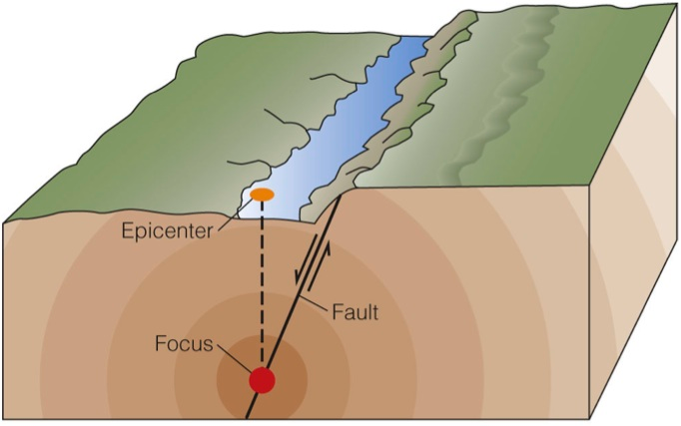
How they Happen:
- Rock on both sides of a fault are pressed together tightly, locked by friction
- When they finally slip, vibrations occur

Focus: The location within the Earth along a fault at which the first motion of an Earthquake occurs

Epicenter: The point on the Earth’s surface above the focus

Waves:
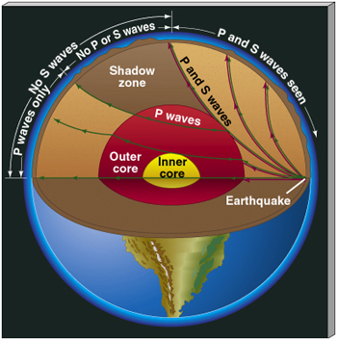
Body Waves: Waves that travel through the Earth

P-Wave: (Primary or Compression Waves)
Motion is back and forth in the direction of travel; fastest of the waves and can travel through solids, liquids, and gases

S-Wave: (Secondary or Shear Waves)
Motion is side to side compared to direction of travel; second fastest and can only travel through solids

Surface Waves: A seismic wave that travels along the surface and has a stronger effect than when it is traveling; slowest waves; converted P & S waves; cause the most damage

Waves in the Earth’s Interior:
- Led to more in depth knowledge of the Earth’s interior
- Various densities and phases are shown by wave deflection
- S waves blocked by liquid outer core
- P waves change direction as they pass through the cores

Determining Location:

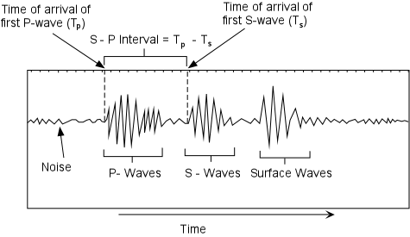
The longer the time difference between the arrival of the P and S waves, the farther away from the epicenter

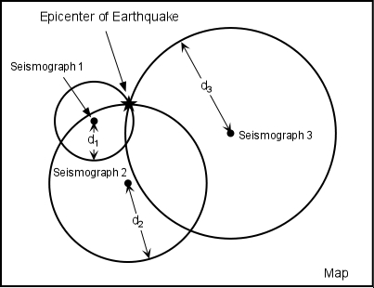
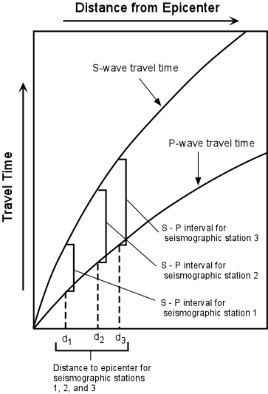

Once you have the distance to the epicenter, using three stations, you can determine the location by creating circles with that distance as the radius. The point where the three circle meet is the location of the epicenter.

