Earthquakes:

Unit 2: Earth’s History

Mini-Unit: Earthquakes

Goal 4: The student will demonstrate the ability to explain the Theory of Plate Tectonics and relate it to Earth’s dynamic nature

Textbook: Chap 12, pg 254

Earthquakes:

___________________________________: A movement or trembling of the ground that is caused by a sudden release of energy when rocks move along a fault line
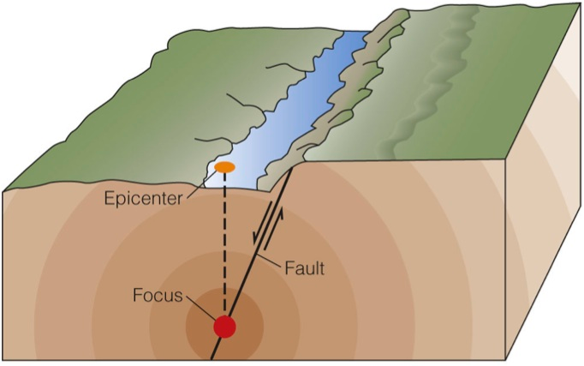
How they Happen:

Focus:

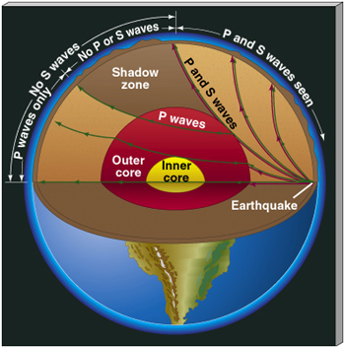
Epicenter:

Waves:

______________________________: Waves that travel through the Earth

P-Wave: (_______________________________)

S-Wave: (____________________________________________)

______________________________________: A seismic wave that travels along the surface and has a stronger effect than when it is traveling; slowest waves; converted P & S waves; cause the most damage

Waves in the Earth’s Interior:
- Led to more in depth knowledge of the ________________________________

- Various ___________________________________________ are shown by wave deflection

- ___________________________ blocked by liquid outer core

- ___________________________ change direction as they pass through the cores

Determining Location:

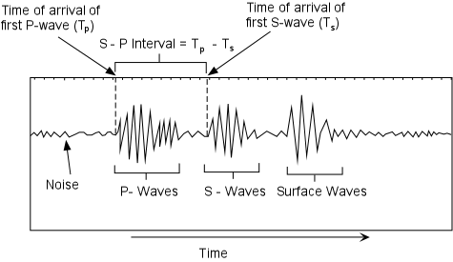
The longer the time difference between the arrival of the P and S waves, the farther away from the epicenter

Once you have the distance to the epicenter, using three stations, you can determine the location by creating circles with that distance as the radius. The point where the three circle meet is the location of the epicenter.
