Atmosphere Notes:

Unit 3: Interactions of the Atmosphere and Hydrosphere

Mini-Unit: Atmosphere

Goal 1: The student will demonstrate the ability to use concepts of system analysis to identify major atmosphere and hydrologic cycle topics and discuss their relationships to other fields of Earth and Space Science

Objectives – The student will be able to:
- Identify and describe the components of the atmosphere and the hydrosphere

Textbook: Unit 7, Chapter 22, p. 546

Atmosphere:
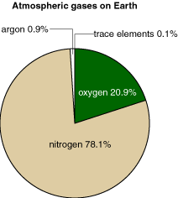
Atmosphere:

Composition:

Atmospheric Particulates:

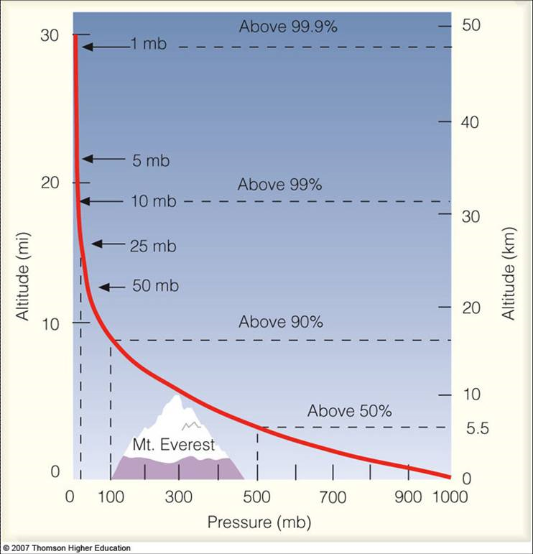
- _____________________________ – from evaporation and transpiration, ranges from 1% (dry) to 4% (moist)

- _____________________________ – O3, absorbs harmful UV radiation, being destroyed by particulates

- _____________________________ – tiny solid particles such as ash, dust, pollen, microscopic organisms

Atmospheric Pressure:

Layers of the Atmosphere:

- Troposphere:

- Stratosphere:

- Mesosphere:

- Thermosphere:

