Heat in the Atmosphere Notes:

Unit 3: Interactions of the Atmosphere and Hydrosphere

Mini-Unit: Atmosphere

Goal 2: The student will demonstrate the ability to analyze the major components, thermal structure, and chemical composition of the atmosphere.

Objectives – The student will be able to:
- Analyze and compare the heat transfer systems (radiation, convection, conduction) affecting atmospheric circulation patterns
- Describe the Earth’s energy budge using the radiative properties (absorption, relection/albedo, and scattering) of the land, water and atmosphere (cloud cover)
- Describe the cause of local and global air and wind patterns, including pressure gradients, density, land and sea breezes, Coriolis effect, and energy exchange

Textbook: Unit 7, Chapter 23, p. 555

Heat in the Atmosphere:

Radiation:

________________________________: All the frequencies and wavelength of radiation
includes radio waves, microwaves, infrared, visible light, UV rays, x-rays, and gamma rays

Layers of the Atmosphere and Solar Radiation:

- __________________________________________ absorb all the wavelengths shorter than visible light such UV, x-rays, and gamma rays
- Carbon dioxide and water vapor absorb infrared rays in ____________________________
- Visible light is barely absorbed

Scattering:

_________________________________: Solar energy that reaches the Earth and reflected back depending on the characteristics such as color, texture, composition, volume, mass, transparency, state of matter, intensity of light, and amount of time exposed

Albedo:

_________________________________: The warming of the surface and lower atmosphere of Earth that occurs when carbon dioxides, water vapor and other gases in the air absorb and reradiate infrared radiation (heat)

Global Warming:
a.

b.

Carbon Cycle:
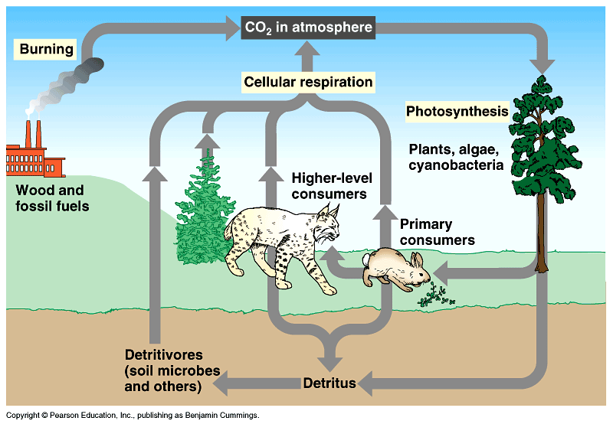

Effect of the Angle of the Sun:
- The more direct sunlight, the __________________________ the temperatures, because the heat energy is more concentrated in a smaller area

- As a result, seasons are determined by the ________________________

- Therefore we are angled towards the sun during ____________________ and away during the _____________________________

- We are closer to the sun during __________________ and farther away during the _____________________

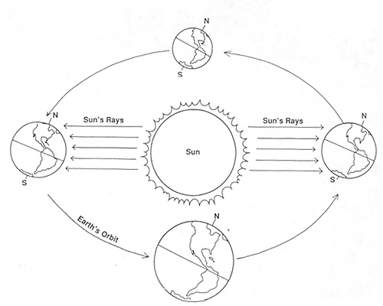
Conduction:

Convection:

