Heat in the Atmosphere Notes:

Unit 3: Interactions of the Atmosphere and Hydrosphere

Mini-Unit: Atmosphere

Goal 2: The student will demonstrate the ability to analyze the major components, thermal structure, and chemical composition of the atmosphere.

Objectives – The student will be able to:
- Analyze and compare the heat transfer systems (radiation, convection, conduction) affecting atmospheric circulation patterns
- Describe the Earth’s energy budge using the radiative properties (absorption, relection/albedo, and scattering) of the land, water and atmosphere (cloud cover)
- Describe the cause of local and global air and wind patterns, including pressure gradients, density, land and sea breezes, Coriolis effect, and energy exchange

Textbook: Unit 7, Chapter 23, p. 555

Heat in the Atmosphere:

Radiation: All energy that travels through space as waves, all are part of the Electromagnetic Spectrum

Electromagnetic Spectrum: All the frequencies and wavelength of radiation
includes radio waves, microwaves, infrared, visible light, UV rays, x-rays, and gamma rays

Layers of the Atmosphere and Solar Radiation:
- Thermosphere and mesosphere absorb all the wavelengths shorter than visible light such UV, x-rays, and gamma rays
- Carbon dioxide and water vapor absorb infrared rays in troposphere
- Visible light is barely absorbed

Scattering: The disruption and bending of solar rays, allows light to come from all directions, causes sky to be blue

Reflection: Solar energy that reaches the Earth and reflected back depending on the characteristics such as color, texture, composition, volume, mass, transparency, state of matter, intensity of light, and amount of time exposed

Albedo: the fraction of solar radiation that is reflected off the surface of an object

Greenhouse Effect: The warming of the surface and lower atmosphere of Earth that occurs when carbon dioxides, water vapor and other gases in the air absorb and reradiate infrared radiation (heat)

Global Warming:
- Usually the amount of solar energy that enters the atmosphere is equal to the solar energy that escapes into space
- Human effects have led to an imbalance or reduction of solar energy escaping to space thus resulting in higher global temperatures through excess carbon dioxide being released

Carbon Cycle:
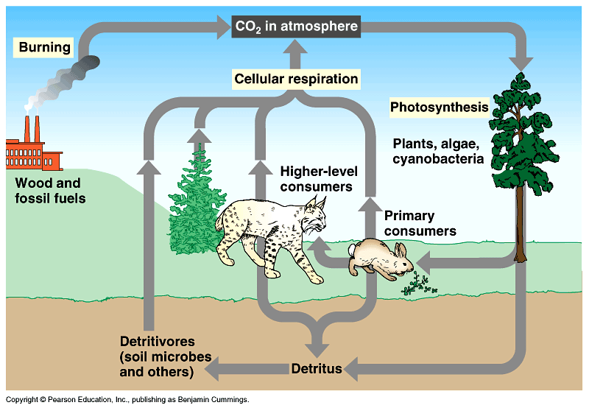

Effect of the Angle of the Sun:
- The more direct sunlight, the higher the temperatures, because the heat energy is more concentrated in a smaller area
- As a result, seasons are determined by the tilt of the earth
- Therefore we are angled towards the sun during summer and away during the winter
- We are closer to the sun during winter and farther away during the summer

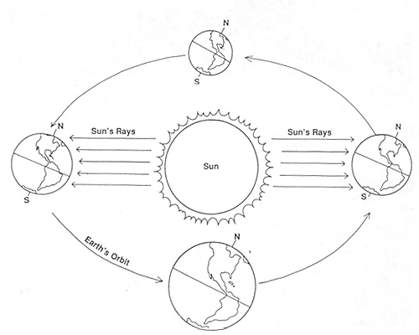

Conduction: The transfer of energy through direct contact or through an object
- the denser the material, the closer the atoms, the better the conductor

Convection: warmer, less dense substances will rise, while colder, more dense substances will sink

