Movement of Air Notes:

Unit 3: Interactions of the Atmosphere and Hydrosphere

Mini-Unit: Atmosphere

Goal 2: The student will demonstrate the ability to analyze the major components, thermal structure, and chemical composition of the atmosphere.

Objectives – The student will be able to:
Describe the cause of local and global air and wind patterns, including pressure gradients, density, land and sea breezes, Coriolis effect, and energy exchange

Textbook: Unit 7, Chapter 24

Cause of Wind Formation:

Wind Formation:
- Wind is caused by ________________________________________________________________

- These temperature differences lead to the creation of _________ pressure and________ pressure areas
- Wind –

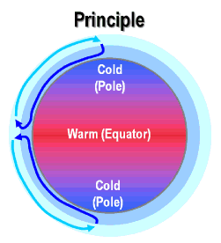
Cause of Temperature Differences:

Density of Air:
- Warm air is less dense than cold air, so it rises
- Cold air sinks and moves along the Earth’s surface.

Coriolis Effect:

Coriolis Effect:

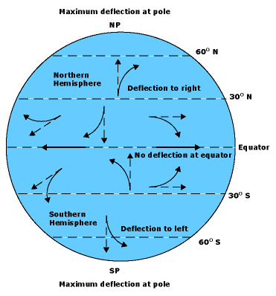

Only perceived, the object/air is moving along a straight line, but the Earth is moving underneath it.

Major Wind Systems:

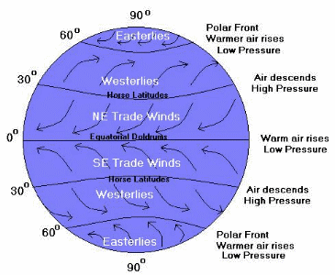
Doldrums:

Trade Winds:

Westerlies:

Polar Easterlies:

High Altitude Winds:

Jet Stream:

Local Winds:

Concept:

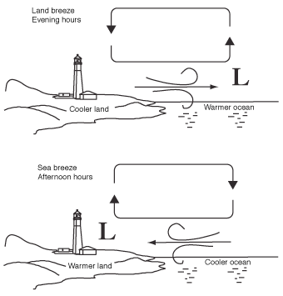
Land Breeze:

Caused by: water cools off slower so its warmer than land after the sun goes down, therefore it warms the air above it and it rises, air above land moves in to replace it

Sea Breeze:

Caused by: land warmed by sun faster, air warms above land first and rises, air above water moves in to replace it

