Movement of Air Notes:

Unit 3: Interactions of the Atmosphere and Hydrosphere

Mini-Unit: Atmosphere

Goal 2: The student will demonstrate the ability to analyze the major components, thermal structure, and chemical composition of the atmosphere.

Objectives – The student will be able to:
Describe the cause of local and global air and wind patterns, including pressure gradients, density, land and sea breezes, Coriolis effect, and energy exchange

Textbook: Unit 7, Chapter 24

Cause of Wind Formation:

Wind Formation:
- Wind is caused by the uneven heating of the Earth and its atmosphere
- These temperature differences lead to the creation of high pressure and low pressure areas
- Wind – the movement of air from an area of high pressure to an area of low pressure
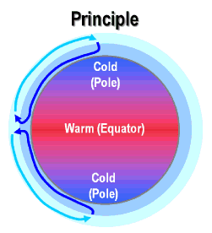
Cause of Temperature Differences:
- Tilt in orbit around the sun
- Curved surface of the Earth
- Equator receives the most radiation, poles receive the least

Density of Air:
- Warm air is less dense than cold air, so it rises
- Cold air sinks and moves along the Earth’s surface.

Coriolis Effect:

Coriolis Effect: The tendency of a moving object to follow a curved path rather than a straight one due to Earth’s rotation
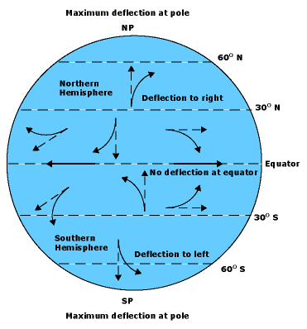
Only perceived, the object/air is moving along a straight line, but the Earth is moving underneath it.

Major Wind Systems:

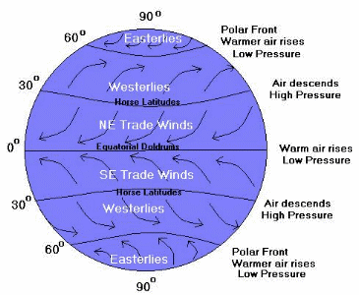
Doldrums: Windless zone at the equator due to hot air rising straight up

Trade Winds: From the equator to 30 degrees latitude North or South, air descending on the Earth’s surface creates steady winds

Westerlies: From 30 degrees to 60 degrees, wind moves from west to east, responsible for movement of weather in the US

Polar Easterlies: Cold air that blows from the Northeast to Southwest near the poles

High Altitude Winds:

Jet Stream: Narrow belt of strong winds near top of troposphere, blow from west to east, average 60-110 miles per hour, position changes daily and seasonally, major effect on weather

Local Winds:

Concept: Land heats up and cools down faster than water

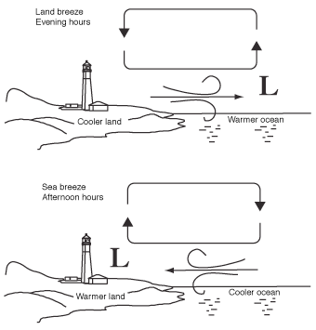
Land Breeze: wind blowing from land to seas during the night

Caused by: water cools off slower so its warmer than land after the sun goes down, therefore it warms the air above it and it rises, air above land moves in to replace it

Sea Breeze: wind blowing from sea to land during the day

Caused by: land warmed by sun faster, air warms above land first and rises, air above water moves in to replace it

