Air Masses Homework:
Pg. 601-604

Name: Date; Period:

Define the following:
Air Mass –

Review:
How does an air mass form:

Fill in the following charts:
Air Masses
Source Region | Type of Air | Symbol
Continental
Maritime
Tropical
Polar

Air Masses of North America
Source Region | Source Location | Movement | Weather
cP
mP
cT
mT
Identify the location of the formation and movement of the four types of air masses, found in six regions, which influence weather in North America
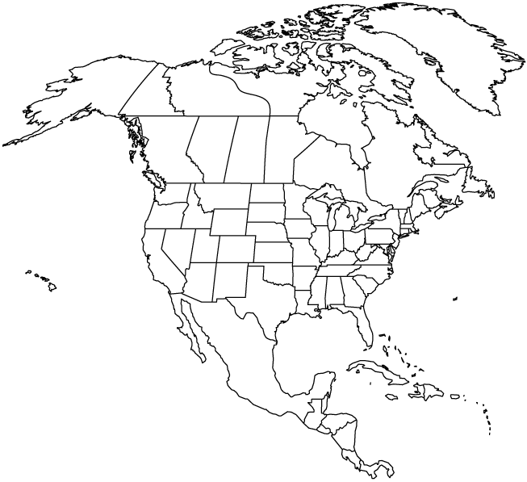

Explain:
How would temperature and humidity at a given location change when a maritime tropical air mass is replaced by a continental polar air mass:

A maritime polar air mass comes down from Alaska to the Northwestern United States. What will be our weather in a few days and why (type of weather, direction of movement of air mass, why it moves the direction it does):

