Water in the Atmosphere Notes:

Unit 3: Interactions of the Atmosphere and Hydrosphere

Mini-Unit: Water in the Atmosphere

Goal 3: The student will demonstrate the ability to explain how the transfer of energy affects the water cycle.

Objectives – The student will be able to:
  - Analyze energy transfer systems that influence phase changes (condensation, melting, deposition, freezing, sublimation, and evaporation) and the latent heat in the atmosphere

Textbook: Unit 7, Chapter 23, pg. 574

Atmospheric Moisture:

3 States of Water in Atmosphere:

- _______________________ – solid

- _______________________ – liquid

- _______________________ – gas

Humidity –

Key Points:

________________________________ – measure of how close the air is to reaching the dew point

- What we call “__________________________________”

- Measured as a __________________________

- At 75% relative humidity, the air has ¾ of the water vapor it can hold

- As relative humidity goes up, the difference between temperature and the dew point decreases

________________________________ – the temperature where the condensation point equals the evaporation point, under this temperature and water droplets form

- The greater the temperature/dew point spread, the less amount of water in the air compared to how much it could hold

- Measured in degrees
- Dew Point: 50 degrees – comfortable
- Dew Point: 60 degrees – humid
- Dew Point: 70 degrees – very uncomfortable

Dew –

Frost –

If the dew point = current temperature = 100% relative humidity = water vapor condenses forming dew

Absolute Humidity –

Clouds and Fog:

Clouds –

Cloud Formation:
- Condensation Nuclei-

- Evaporation rate must be in equilibrium with condensation, “______________________”

- As temperature of the saturated air drops, condensation occurs more than evaporation, and clouds form

Cooling Processes for Cloud Formation:

- _________________________________________ – The process by which the temperature of an air mass decreases as an air mass rises and expands due to a decrease in air pressure, thus a decrease in particle collisions, thus lower temperatures

- Mixing –

- _______________________________________ – The forced upward movement of air either by a mountain range or another air mass going underneath it and lifting it (storms)
- Advective Cooling –

Classification of Clouds:

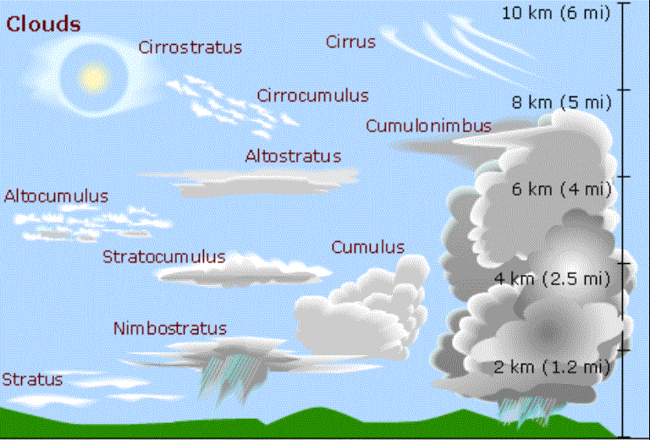
Stratus Clouds:

Cumulus Clouds:

Cirrus Clouds:

Fog:

Precipitation:

Precipitation –

______________________ – liquid precipitation

Snow –

______________________ – rain that freezes on the way down to Earth

Freezing Rain -

______________________– solid precipitation that is a ball of ice that cycles in the clouds, the more cycling the bigger the hail

