Water in the Atmosphere Notes:

Unit 3: Interactions of the Atmosphere and Hydrosphere

Mini-Unit: Water in the Atmosphere

Goal 3: The student will demonstrate the ability to explain how the transfer of energy affects the water cycle.

Objectives – The student will be able to:
  - Analyze energy transfer systems that influence phase changes (condensation, melting, deposition, freezing, sublimation, and evaporation) and the latent heat in the atmosphere

Textbook: Unit 7, Chapter 23, pg. 574

Atmospheric Moisture:

Condensation

Precipitation

Transpiration Evaporation

3 States of Water in Atmosphere:
- Ice – solid
- Water – liquid
- Water Vapor – gas

Humidity – water in the atmosphere

Key Points:
- Warm air can hold more water than cold air
- Dew point and relative humidity are related

Relative Humidity – measure of how close the air is to reaching the dew point
- What we call “humidity”
- Measured as a percent
- At 75% relative humidity, the air has ¾ of the water vapor it can hold
- As relative humidity goes up, the temperature/dew point spread decreases

Dew Point – the temperature where the condensation point equals the evaporation point, under this temperature and water droplets form
- The temperature to which the present air would have to be lowered to become saturated
- The greater the temperature/dew point spread, the less amount of water in the air compared to how much it could hold
- Measured in degrees
- Dew Point: 50 degrees – comfortable
- Dew Point: 60 degrees – humid
- Dew Point: 70 degrees – very uncomfortable

Dew – when the temperature drops to the dew point and air comes in contact with the cooler ground

Frost – when the dew point falls below the freezing temperature of water, water vapor goes straight to ice, therefore it is not frozen dew

If the dew point = current temperature = 100% relative humidity = water vapor condenses forming dew

Absolute Humidity – measure of the actual amount of water vapor in the air; mass of the water vapor in the air per unit of mass of air

Clouds and Fog:

Clouds – a collection of small water droplets or ice crystals suspended in the air, which forms when the air is cooled and condensation occurs.

Cloud Formation:
- Condensation Nuclei - In order for water to condense and form a cloud, a solid surface for condensation to occur on must be available
- Evaporation rate must be in equilibrium with condensation, “saturated air” (At dew point)
- As temperature of the saturated air drops, condensation occurs more than evaporation, and clouds form

Cooling Processes for Cloud Formation:
- Adiabatic Cooling – The process by which the temperature of an air mass decreases as an air mass rises and expands due to a decrease in air pressure, thus a decrease in particle collisions, thus lower temperatures
- Mixing – When a body of moist air mixes with another body of moist air that is cooler
- Lifting – The forced upward movement of air either by a mountain range or another air mass going underneath it and lifting it (storms)
- Advective Cooling – The process by which the temperature of an air mass decreases as the air mass moves over a cold surface such a cold ocean or land surface

Classification of Clouds:
- Shape
- Altitude
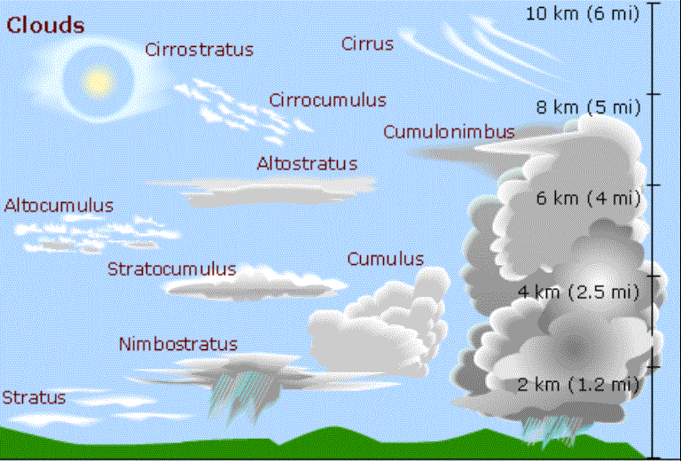
Stratus Clouds:
- Flat uniform base
- Form at low altitudes
- Typically wide gray clouds with no precipitation

Cumulus Clouds:
- Puffy, billowy cloud
- Form at low altitudes
- On hot humid days the cloud can climb up high and form storm clouds called cumulonimbus

Cirrus Clouds:
- Feathery clouds
- High altitudes
- Composed of ice crystals

Fog:
- Very low altitude
- Forms differently from other clouds, either warm air comes in contact with the cool ground or flows over cool water

Precipitation:

Precipitation – any form of water that falls to Earth’s surface from the clouds; includes rain, snow, sleet, hail and freezing rain

Rain – liquid precipitation

Snow – solid ice precipitation that fall as pellets, crystals, or groups of crystals called snowflakes

Sleet – rain that freezes on the way down to Earth

Freezing Rain – rain that does not freeze until it hits the ground

Hail – solid precipitation that is a ball of ice that cycles in the clouds, the more cycling the bigger the hail

