Air Masses and Fronts:

Unit 3: Interactions of the Atmosphere and Hydrosphere

Mini-Unit: Weather

Goal 3: The student will demonstrate the ability to explain how the transfer of energy affects the water cycle.

Objectives – The student will be able to:
  - Identify causes of vertical air motion and their effects on cyclones and anticyclones

Textbook: Unit 7, Chapter 24, pg. 600 & Chapter 25, pg. 630

Air Masses:

Air moves from areas of __________________ pressure to _________________pressure, which are caused by:

Air Mass:

Types of Air Masses:
- Classified by their __________________________ and _____________________________ which are dependent upon the area over which they formed

- Continental –

- Maritime -

- Tropical –

- Polar –

Air Mass | Symbol | Formed Over | Weather
Continental Tropical
 | cP
 |  | Warm water
 |  |  | Cold and wet

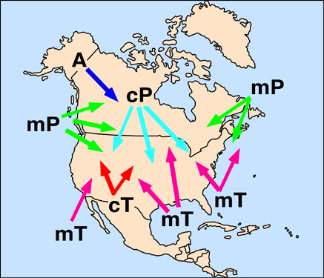

Fronts:

Fronts:

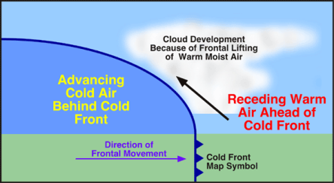
Cold Front:

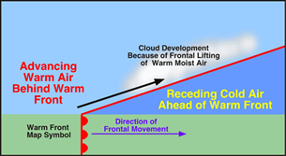
Warm Front:

Stationary Front:

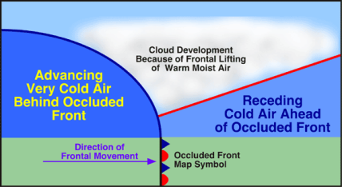
Occluded Front:

Cyclones and Anticyclones:

Cyclone:

- Usually lasts several days
- Spin counter clockwise
- Follow storm tracks or routes

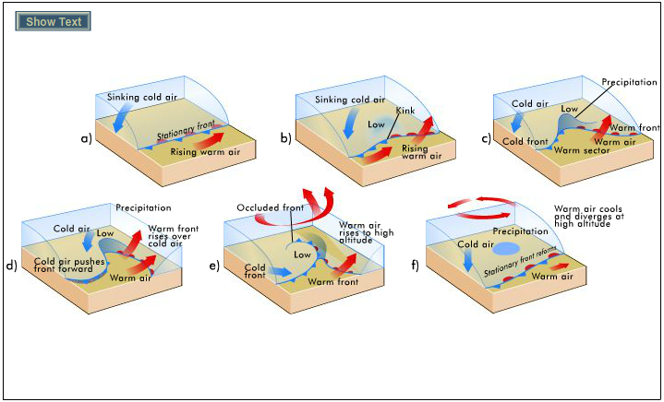

Anticyclones:

