Air Masses and Fronts:

Unit 3: Interactions of the Atmosphere and Hydrosphere

Mini-Unit: Weather

Goal 3: The student will demonstrate the ability to explain how the transfer of energy affects the water cycle.

Objectives – The student will be able to:
  - Identify causes of vertical air motion and their effects on cyclones and anticyclones

Textbook: Unit 7, Chapter 24, pg. 600 & Chapter 25, pg. 630

Air Masses:

Air moves from areas of high pressure to low pressure, which are caused by the uneven heating of the Earth’s surface

Air Mass: A large body of air throughout which temperature and moisture content are similar
- Take on the characteristics of the area over which they sit and remain stationary

Types of Air Masses:
- Classified by their temperature and moisture content which are dependent upon the area over which they formed

- Continental – dry air masses that formed over land (c)
- Maritime - moist air masses that formed over water (m)
- Tropical – warm air masses that formed over warm areas (T)
- Polar – cold air masses that formed over cold areas (P)

Air Mass | Symbol | Formed Over | Weather
Continental Tropical | cT | Warm land | Warm and dry
Continental Polar | cP | Cold land | Cold and dry
Maritime Tropical | mT | Warm water | Warm and wet
Maritime Polar | mP | Cold water | Cold and wet
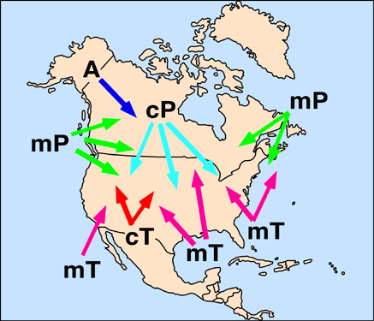

Fronts:

Fronts:
Boundaries between air masses; dense cold air does not mix with less dense warm air; do not exist in tropics because no real temperature differences

Cold Front:
The front edge of a moving mass of cold air that pushes beneath a warm air mass like a wedge; results in precipitation if warm air mass is humid, severe storms if cold front moves quickly
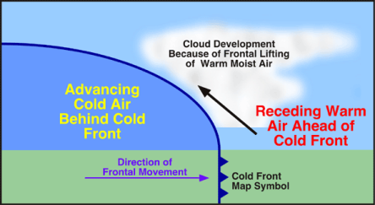

Warm Front:
The front edge of advancing warm air mass that replaces cold air with warmer air; generally results in precipitation over a large area
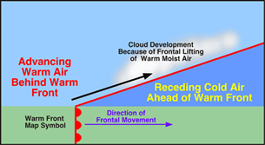

Stationary Front:
A front of air masses that move either very slowly or not at all, weather similar to a warm front

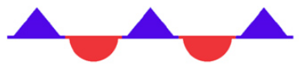

Occluded Front:
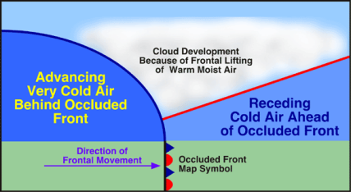
A front that forms when a cold air mass overtakes a warm air mass and lifts the warm air mass of the ground and over another air mass

Cyclones and Anticyclones:

Cyclone: A low pressure storm system that is characterized by rotating wind that moves towards the rising air of the central low pressure region

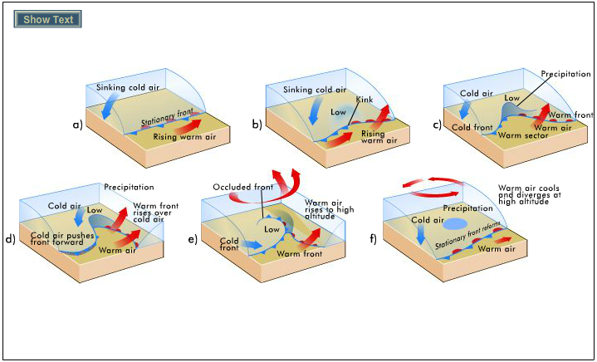

- Usually lasts several days
- Spin counter clockwise
- Follow storm tracks or routes

Anticyclones: Flows outward from a center of high pressure in a clockwise motion
- Bring dry weather because of sinking air in the middle does not promote cloud formation

