Our Solar System:

Unit 4: Astronomy

Mini-Unit: Our Solar System

Goal 3: The student will demonstrate the ability to explain the role and interaction of revolution, rotation, and gravity on the components of the Sun-Moon-Earth system.

Textbook: Unit 8, Chapter 27, pg. 685

Formation of the Solar System:

Solar System:

Planet:

Solar Nebula:

_____________________________________:
Formed from much heavier elements such as iron and nickel, with the densest layers settling in the center. Smaller, rockier, and denser than the outer planets.

Includes: _____________________________________________________________________________

_____________________________________:
Formed in a much colder area, thus they did not lose their gases (helium and hydrogen). Larger, gaseous planets

Includes: ____________________________________________________________________________

Dwarf Planets:
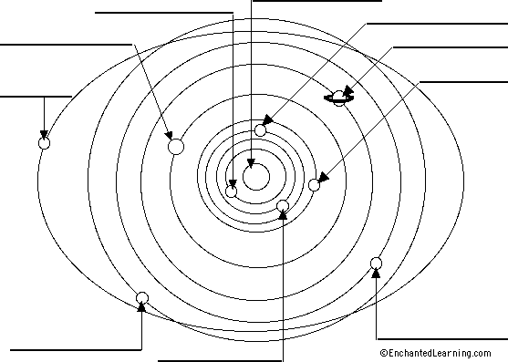
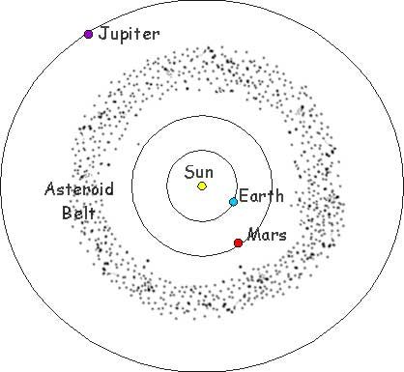
Includes: Pluto

