The Moon:

Unit 4: Astronomy

Mini-Unit: Our Solar System

Goal 3: The student will demonstrate the ability to explain the role and interaction of revolution, rotation, and gravity on the components of the Sun-Moon-Earth system.

Objectives – The student will be able to:
- Describe the Sun-Moon-Earth system
- Explain how the movements and distances (perigee, apogee) between Earth and Moon produce tides including the relationship between phases and tides and tidal bulge and rate of lunar revolutions
- Explain the length of visibility of the moon, the monthly variations in lunar position, and how often eclipses occur per year

Textbook: Unit 8, Chapter 28, pg. 719

Earth’s Moon:

Satellite:

______________________: A celestial body that revolves around a body that is larger in mass; a natural satellite

Characteristics of the Moon:

- The moon has _______________ the gravity of the Earth

- Has no ________________________, so temperatures range from 134 degrees to -170 degrees Celsius

- Mare –

- ______________________________ – deep depressions on the surface of the moon from collisions a billion years old

- ______________________________ – dust and rock created from repeated meteorite collisions that covers the Moon’s surface

The Formation of the Moon:

Movements of the Moon:
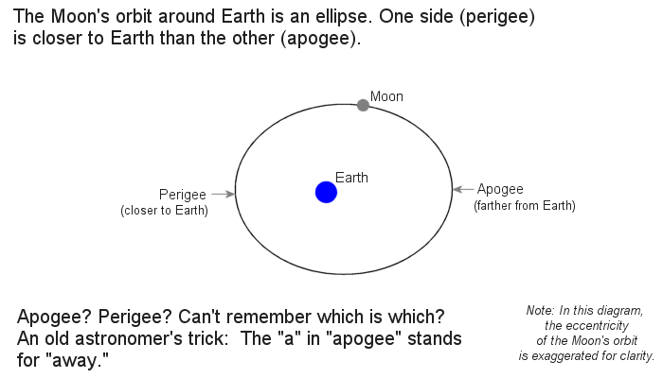
The moon orbits the Earth on an ellipse:

- Apogee:

- Perigee:

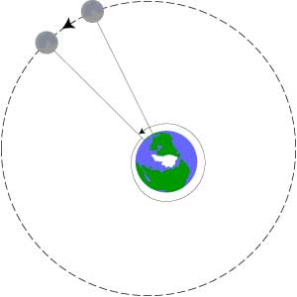
Moonrise & Moonset:
The moon rises or sets about 50 minutes later each day because the Earth’s rotation has to catch up to the Moon’s revolution

It takes the moon ________________________ to revolve around the Earth

Eclipses:

Eclipse: An event in which the shadow of one celestial body falls on another
Two Parts:
- Umbra –

- _______________________________ – outer part in which sunlight is only partially blocked
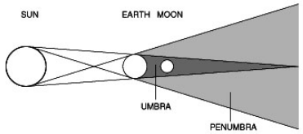

Solar Eclipse:

Lunar Eclipse:

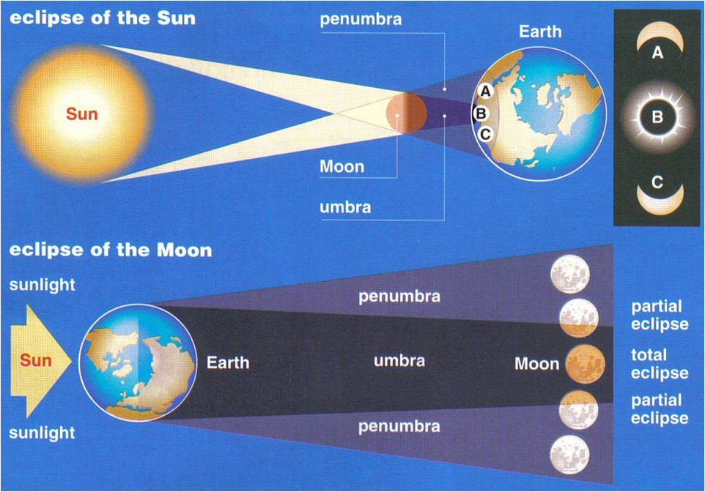

Phases of the Moon:

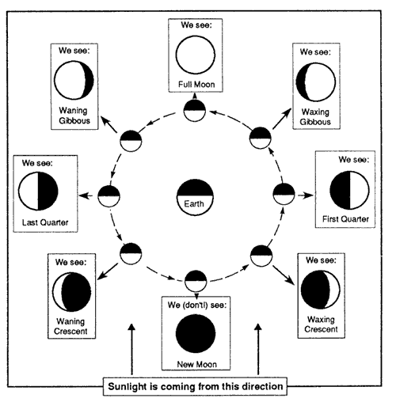

Phase:

Moon phases are caused by the __________________________ around the Earth and the light from the Sun reflected

Terms:
- _____________________ – we only see the non-illuminated side of the moon

- _____________________ – the amount of illumination is getting larger (New to Full Moon)

- _____________________ – we see the entire illuminated side of the moon

- _____________________– the amount of illumination is getting smaller (Full Moon to New Moon)

- _____________________ – When less than half of the moon is illuminated

- _____________________ – When more than half of the moon is illuminated

Tides:
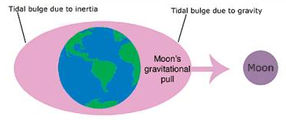
Tides:

- The moon has a larger impact because it is much closer than the sun is, despite how much bigger the sun is

Frequencies of Tides:
Earth’s Rotation: __________________
Lunar Day: 24 hours 50 mins
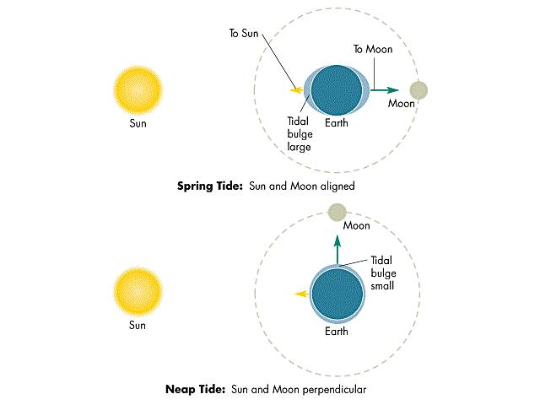
Therefore: A point on Earth will experience two high tides and two low tides every lunar day (24 hours 50 mins)

Spring Tides:

Neap Tides:

