The Moon:

Unit 4: Astronomy

Mini-Unit: Our Solar System

Goal 3: The student will demonstrate the ability to explain the role and interaction of revolution, rotation, and gravity on the components of the Sun-Moon-Earth system.

Objectives – The student will be able to:
- Describe the Sun-Moon-Earth system
- Explain how the movements and distances (perigee, apogee) between Earth and Moon produce tides including the relationship between phases and tides and tidal bulge and rate of lunar revolutions
- Explain the length of visibility of the moon, the monthly variations in lunar position, and how often eclipses occur per year

Textbook: Unit 8, Chapter 28, pg. 719

Earth’s Moon:

Satellite: A natural or artificial body the revolves around a larger celestial body

Moon: A celestial body that revolves around a body that is larger in mass; a natural satellite

Characteristics of the Moon:
- The moon has 1/6th the gravity of the Earth
- Has no atmosphere, so temperatures range from 134 degrees to -170 degrees Celsius
- Mare – dark areas of solidified lava billions of years old (looked like seas)
- Craters – deep depressions on the surface of the moon from collisions a billion years old
- Regolith – dust and rock created from repeated meteorite collisions that covers the Moon’s surface

The Formation of the Moon:
Collision between Earth and a giant Mars-sized body ejected magma into space which settled into an orbit and clumped together

Movements of the Moon:
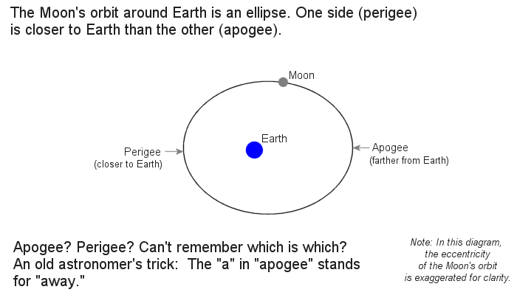
The moon orbits the Earth on an ellipse:
- Apogee: the point at which the moon is farthest from the Earth
- Perigee: the point at which the moon is closest to the Earth

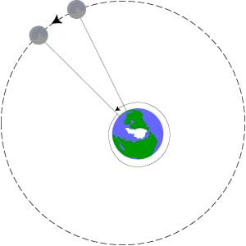
Moonrise & Moonset:
The moon rises or sets about 50 minutes later each day because the Earth’s rotation has to catch up to the Moon’s revolution

It takes the moon 27.3 days to revolve around the Earth

Eclipses:

Eclipse: An event in which the shadow of one celestial body falls on another
Two Parts:
- Umbra – inner, cone-shaped part in which sunlight is completely blocked
- Penumbra – outer part in which sunlight is only partially blocked
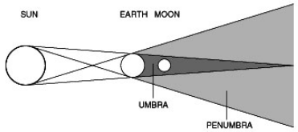

Solar Eclipse: The passing of the moon between the Earth and the sun; during a solar eclipse, the shadow of the moon falls on Earth

Lunar Eclipse: The pass of the moon through Earth’s shadow at full moon
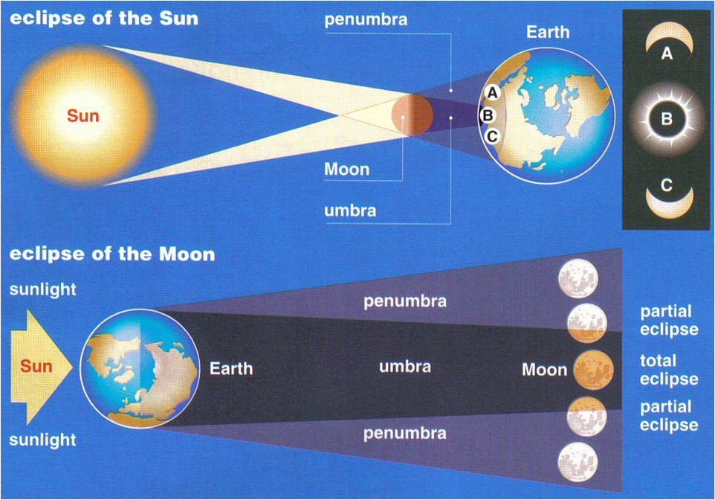

Phases of the Moon:

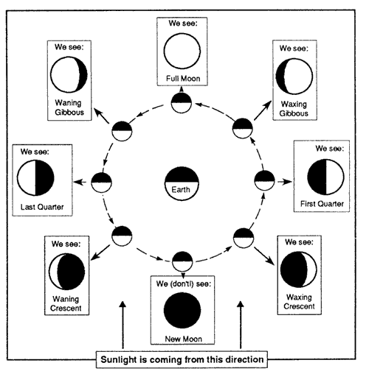

Phase: the change in the illuminated area of one celestial body as seen from another celestial body

Moon phases are caused by the moon’s revolution around the Earth and the light from the Sun reflected

Terms:
- New Moon – we only see the non-illuminated side of the moon
- Waxing – the amount of illumination is getting larger (New to Full Moon)
- Full Moon – we see the entire illuminated side of the moon
- Waning – the amount of illumination is getting smaller (Full Moon to New Moon)
- Crescent – When less than half of the moon is illuminated
- Gibbous – When more than half of the moon is illuminated

Tides:
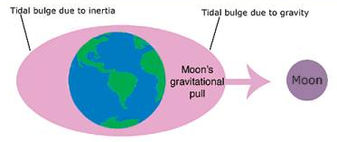
Tides:

Bulges or depressions in water levels caused by the force of gravity exerted by the Sun and Moon

- The moon has a larger impact because it is much closer than the sun is, despite how much bigger the sun is

Frequencies of Tides:
Earth’s Rotation: 24 hours
Lunar Day: 24 hours 50 mins
Therefore: A point on Earth will experience two high tides and two low tides every lunar day (24 hours 50 mins)

Spring Tides: When the moon and the sun line up along the line of pull you have larger high tides and lower low tides, greater change between the two

Neap Tides: When the moon and the sun are at 90 degrees to each other, you have lower high tides and higher low tides, so less change between the two

