Module 1: Density

Name: Date: Period:

Part I: Introduction to Density

Density is a measure of how much matter is found in a specific volume. The measure of the amount of matter is called mass and is measured in grams (g, kg, mg, etc.) as a base unit. Volume is either measure with a base unit of liters (L, mL) or meters cubed (m³, cm³). To get an initial understanding of density, take a look at the two diagram below and write your observations in regards to mass and volume and inferences in regards to the density of the two objects:

Diagram 1: | Diagram 2:
Observations: | Observations:
Inferences | Inferences

In order to calculate density, all we need to be able to do is to divide when given the mass and volume of an object. Density is calculated by taking the mass of an object and dividing by its total volume:
Density = __Mass__
Volume

Try the following examples. Be sure to show your work and label with their units (Round to the nearest hundredths):

- What is the density of a 5.75 gram object with a volume of 3.21 cm³?

- What is the density of a 854.0 mg substance with a volume of 45.7 mL?

Part II: Equation Manipulation

At time you are going to have to figure out the volume of an object given its mass and density or you will need to figure out the mass of an object given its density and volume. See if you can figure out the two problems below using any strategies you can think of:

- What is the volume of substance that has a density of 4.5 g/mL and a mass of 74 grams?

- What is the mass of an object with a density of .56 g/mL and a volume of 34 cm³?

You might have unknowingly or knowingly used skills you learned in algebra when you solved for X. If you struggle with algebra skills, then you can fall back on using the following diagram as a means to solve density problems:
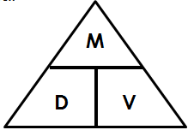

To use the above diagram, simply put your finger over what you are trying to find. The remaining parts of the triangle will give you a hint on how to solve the problem. For example, if you need to find volume, you put your finger on the V. This leaves the M over the D, which implies you need to divide the mass by the density.

Use the various strategies we have introduced to solve the following problems.

For each problem provide the: 1. Formula 2. Substitutions 3. Answer (with units)

- Find the density of a substance whose volume is 5 cm³ and whose mass is 25g.

- Calculate the mass of a substance whose density of 0.2g/cm³ and whose volume is 45 cm3.

- Find the volume of a substance whose density is 4g/cm³ and mass is 4.1g.

- Find the mass of a substance whose density is 8.1 g/cm³ and volume is 2.95 cm³.

- Find the volume of a substance whose density is 1.93 g/cm and mass is 31.3 g.

- Calculate the volume of a substance whose density is 0.90 g/cm³ and mass is 7.1g.

- Calculate the mass of a substance whose volume is 3.15 mL and density is 0.79 g/cm³.

- If a substance has a volume of 5.1 mL and a mass of 2.7 g, what is its density?

- If a container of a substance is 10 mL and its density is 1.26 g/cm³. What is its mass?

Part III: Conservation of Density

Consider a cube whose front edge is 2 cm long . . . how long are all the sides of the cube:______

Cut in half

Mass = 16g Mass:_________________g

Volume:______________cc Volume:______________cc

Density:_______________g/cc Density:_______________g/cc

Cut in half

Cut in half

Mass:_________________g Mass:_________________g

Volume:______________cc Volume:______________cc

Density:_______________g/cc Density:_______________g/cc

Conclusion:

The__________________________________ and ________________________________ of an object can

change, but the density will ________________________________________________________.

Part IV: Earth Science Application of Density

Temperature affects the density of a liquid. Density differences can cause convection cells to form. Convection is a pattern of heat movement that takes place within fluids (liquids and gases). An example is the constant turning of the waters in the oceans. Cold water from polar regions mixes with warmer water at lower latitudes. The colder, denser water sinks below the less dense, warmer water and moves towards the equator. As it becomes warmer and less dense, it begins to rise again and go through the cycle again.

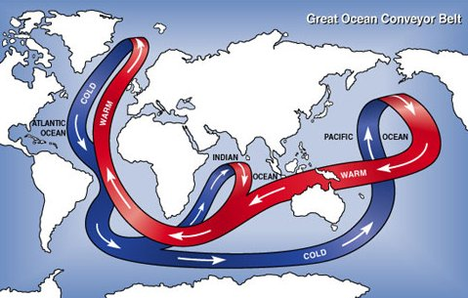

Convection currents occur in any fluid environment and have been identified within the earth’s lithosphere, as well as the atmosphere. For example, air near the equator is warmed and becomes less dense. Cooling, denser air from more northerly and southerly latitudes rushes and pushes the warm, less dense air upward. The warm air travels upward for several miles and then begins to cool. As it cools, it becomes denser than the air around it, spreads out and falls towards the equator again. These constantly moving cells of warm and cold air are known as Hadley Cells and the continual flow of this air along the surface of the Earth is known as wind.

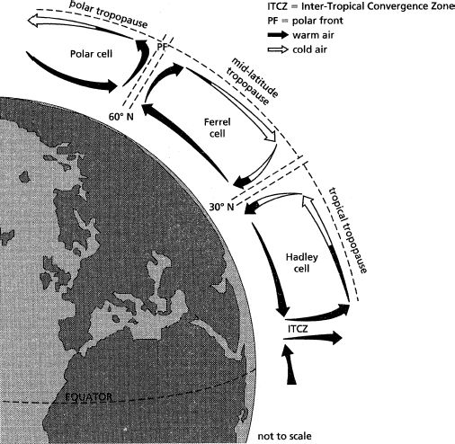

Geologists believe that the rocks within the Earth behavior in the same way. Some of the rock within the mantle is thought to be in a semisolid state due to intense pressure and temperature. This rock has the consistency of warm wax or heated plastic and is able to move or flow. Convection may be occurring from the top of the mantle to the bottom in numerous “cells”. When the hot rock reaches the upper mantle, where the temperatures are lower, the heat is lost through the crusts. As the rock cools, it becomes denser and sinks back down. Just as a hot air balloon will rise when surrounded by cooler air, any hot fluid will travel upward in relation to the cooler surrounding fluid.

