Weathering and Erosion:

Unit 1: Materials and Processes that Shape a Planet

Mini-Unit: Rocks

Goal 3: The student will demonstrate the ability to explain how rock formation, weathering, sedimentation, and rock reformation constitute a continuing “rock cycle” in which the total amount of material stays the same even as its form changes

Objectives – The student will be able to:
- Explain the role of gravity and natural agents (water, wind, glaciers) on Earth (landform changes) and how they impact the rock cycle
- Explain the principles of hydrology, including evaporation, transpiration, surface and groundwater flows, aquifers, porosity, water retention, permeability, particle surface area, desalinization, and sources of water contamination and pollution

Textbook: Unit 5, Chapters 14, p. 340

Weathering and Erosion:

Weathering – the natural process by which atmosphere and environmental forces, such as wind, rain, and temperature changes, disintegrate, and decompose rocks

- Mechanical – the process by which rocks break down into smaller pieces by physical means
- Chemical – the process by which rocks break down as a result of chemical reactions

Types of Mechanical/Physical Weathering:

- Ice Wedging – when water gets into the cracks of rocks, freezes and expands putting stress or breaking the rock
- Abrasion – when rocks rub against each other, usually fragments being carried by agents of erosion, leads to rounding of particles
- Plant or Animal Activity – the roots of plants or the displacement of rocks or soil by animals contribute to erosion
- Changes in Temperature – the daily expanding and contraction of rocks due to changing temperatures

Types of Chemical Weathering:

- Oxidation – process in which elements combine with oxygen, commonly occurs in rock that has iron in it
- Hydrolysis – an chemical reaction of a substance with water, thus minerals will dissolve in water
- Acid Rain – precipitation that contains a high concentration of acid due to pollution

Factors that Affect the Rates of Weathering:

- Rock Composition – density and composition changes the rate of erosion
- Surface Area – the more surface area exposed, the faster the weathering
- Fractures and Joints – naturally forming cracks make the rocks weaker
- Climate – alternating hot and cold weather allows for faster weathering, as well as hot and humid
- Topography – steep slopes allow for faster erosion

Sediment – fragments or particles of rock produced by weathering, named according to size

Particle Size | Name
<.0004 cm | Clay
.0004-.006 cm | Silt
.006-.2 cm | Sand
.02-6.4 cm | Pebbles

Deposition – process by which transported sediment is dropped in new places by agents of erosion

Horizontal Sorting/Deposition – particles carried by a stream or wind begin to be deposited as velocity decreases, thus larger particles are deposited first and smaller particles are carried further

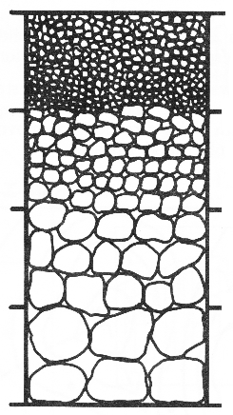
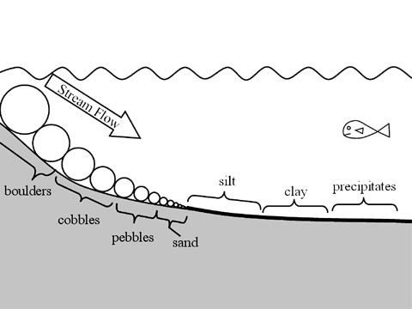

Vertical Sorting/Deposition – larger or more dense particles will settle first, smaller or less dense particles take a little longer

