Plate Tectonics:

Unit 2: Earth’s History

Mini-Unit: Plate Tectonics

Goal 2: The student will demonstrate the ability to explain the Theory of Plate Tectonics and relate it to Earth’s dynamic nature

Objectives – The student will be able to:
- Summarize the evidence and thinking the resulted in the development of the Theory of Plate Tectonics
- Explain plate tectonics in terms of magnetic reversals and outer core circulation, mantle convection, sea floor spreading, and subduction
- Describe how the Theory of Plate Tectonics explains the location of earthquakes, volcanoes, hot spots, mountains, mid-ocean ridges, deep sea trenches, and island arcs
- Give examples of how progressive changes on Earth’s surface, including Pangea, are used to document the evolution of Earth through time

Textbook: Unit 4, Chapters 10, p. 238

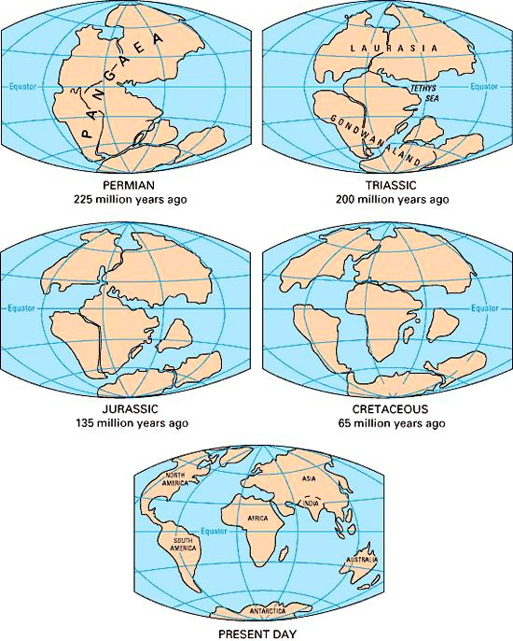
Continental Drift:

Theory of Continental Drift:
Proposed by Alfred Wegener in 1912; the hypothesis that states that the continents once formed a single landmass (Pangea), broke up, and drifted to their current location

Wegeners’s Evidence:
- Shape of the continents
- Fossil evidence that showed up on both sides of the Atlantic
- Rock formations that showed up on both sides of the Atlantic
- Climatic evidence (i.e. evidence of glaciers in Southern Africa)

Problems with Theory:
He could not come up with the mechanism or process that allowed the continents to move

Missing Evidence:
- Mid-Ocean Ridges – a long, undersea mountain chain that has a steep, narrow valley at its center, that form as magma rises from the mantle, and that creates new ocean floor as tectonic plates move apart
- Sea Floor Spreading – The process by which new oceanic crust forms as magma rises to Earth’s surface and solidifies at a mid-ocean ridge, symmetry of rock layers show oldest layers are farther from the mid-ocean ridge
- Paleomagnetism –
  - As magma solidifies, iron particles lines up with the Earth’s magnetic field
  - Rocks show reversals in the Earth’s magnetism
  - Rocks show symmetrical patterns on both side of the ridges, thus both plates formed at same time

How Continents Move:

Plate Tectonics – the theory that explains how large pieces of the crust, called plates, move and change shape

Lithosphere – solid, outer layer of Earth that consists of the crust and the rigid upper part of the mantle

Athenosphere – the solid, plastic layer of the mantle the flows slowly

Tectonic Plates – scientists have identified 15 major plates
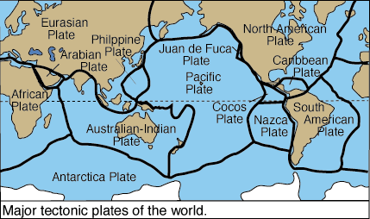

Causes of Plate Motion:

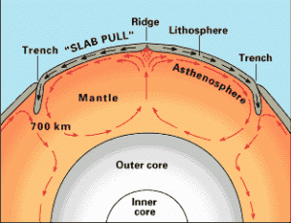
Convection – the movement of hot, less dense material up and cold, more dense material down

Mantle Convection:
- Interior of the Earth heats the mantle which rises to the surface at Mid-Ocean Ridges
- Cools into rock and eventually sinks back into the mantle where it is melts and sinks
- This movement of the mantle drags the plates with it

Plate Boundaries:

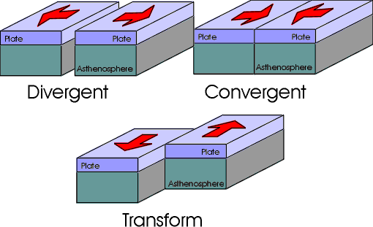

Divergent Boundaries: The boundary between tectonic plates that are moving away from each other
Results in: magma rises to surface, forms mid-ocean ridges and rift valleys

Convergent Boundaries: The boundary between tectonic plates that are moving towards each other
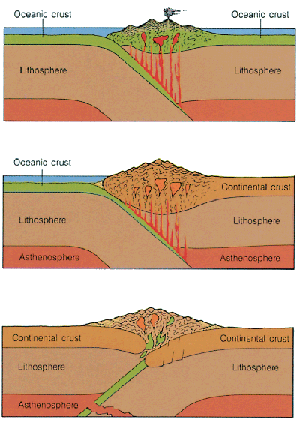
- Oceanic-Oceanic – one plate subducts under the other, forming a trench and melting the plate causing an island arc

- Oceanic-Continental – the oceanic plate subducts under the less dense continental plate, the oceanic plate melts, causing volcanoes above

- Continental-Continental – neither plate is dense enough to subduct, thus mountains are built up

Transform Boundaries: The boundary between two tectonic plates that are sliding past one another, like the San Andreas fault

Results of Plate Tectonics:

Earthquakes – created by the sudden movement of tectonic plates, typically occur along plate boundaries

Volcanoes – places where magma erupts from the surface

Ring of Fire – an area around the Pacific Ocean characterized by volcanoes and seismic activity
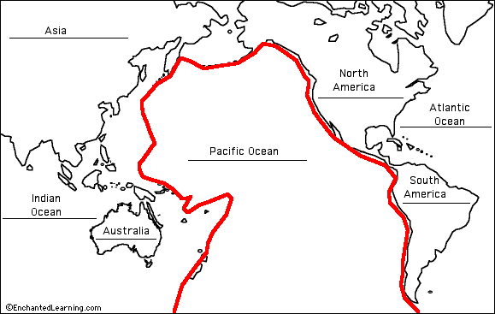

Hot Spots – Areas where magma reaches the surface, under the plates so the plates do not move, creates island arcs like Hawaii
