**Relative Dating:**

**Unit 2: Earth’s History**

**Mini-Unit:** Age of Rocks

**Goal 2**:The student will demonstrate the ability to explain how artifacts and events of Earth’s past are dated.

**Objectives – The student will be able to:**

* Compare similarities and differences between relative age and absolute age
* Describe the principles used to determine relative age, including Law of Superposition, Principle of Horizontality, Principle of Crosscutting Relationships, Law of Included Fragments, unconformities, intrusions, rock layer correlation, and fossil correlation

**Textbook:** Unit 3, Chapter 8, p. 184

Determining Relative Age:

Uniformitarianism –

* Proposed by James Hutton in the 1800’s, groundbreaking because it suggested the Earth was millions of years old as opposed to thousands.

_____________________________________ – the age of an object in relation to the ages of other objects, typically with layers of sedimentary rock

Laws and Principles:

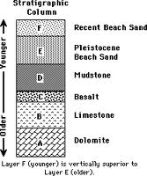

Law of Superposition –

____________________________________________ – Sedimentary rocks that are left undisturbed will remain in horizontal layers, therefore, layers that have been tilted or deformed by crustal movements were done after it formed

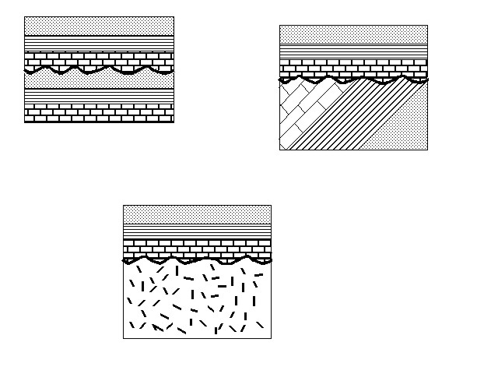Unconformity –

Law of Crosscutting Relationships –

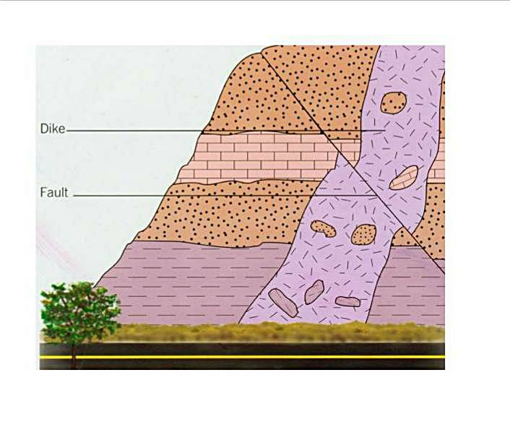

Law of Inclusions -

Label or identify all the laws, principles and ideas on the model below:

