**Relative Dating:**

**Unit 2: Earth’s History**

**Mini-Unit:** Age of Rocks

**Goal 2**:The student will demonstrate the ability to explain how artifacts and events of Earth’s past are dated.

**Objectives – The student will be able to:**

* Compare similarities and differences between relative age and absolute age
* Describe the principles used to determine relative age, including Law of Superposition, Principle of Horizontality, Principle of Crosscutting Relationships, Law of Included Fragments, unconformities, intrusions, rock layer correlation, and fossil correlation

**Textbook:** Unit 3, Chapter 8, p. 184

Determining Relative Age:

Uniformitarianism – a principle that geological processes that occurred in the past can be explained by current geologic processes

* Proposed by James Hutton in the 1800’s, groundbreaking because it suggested the Earth was millions of years old as opposed to thousands.

Relative Age – the age of an object in relation to the ages of other objects, typically with layers of sedimentary rock

Laws and Principles:

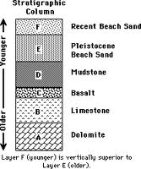

Law of Superposition – The law that a sedimentary rock layer is older than the layers above it and younger than the layers below it if the layers are not disturbed

Principle of Original Horizontality – Sedimentary rocks that are left undisturbed will remain in horizontal layers, therefore, layers that have been tilted or deformed by crustal movements were done after it formed

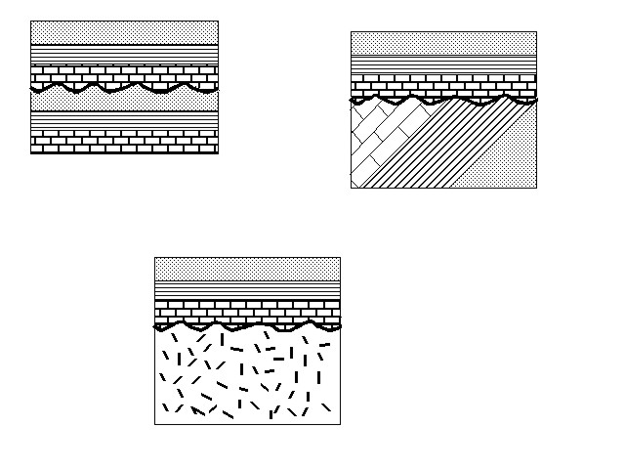Unconformity – a break in the geological record created when rock layers are eroded or when sediment is not deposited for a long period of time

Law of Crosscutting Relationships – The principle that a fault or body of rock is younger than any other body of rock that it cuts through

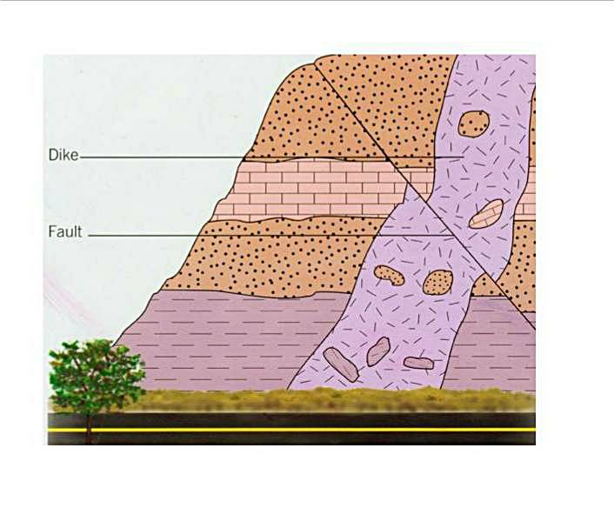

Law of Inclusions – If one rock body contains fragments of another rock body, it must be younger than the fragments of rock

Label or identify all the laws, principles and ideas on the model below:

