Atmosphere Inquiry Activity:

Name: Date: Period:
Activity 1: Background Reading:
On earth, two elements, nitrogen (N₂) and oxygen (O₂), make up almost 99% of the volume of clean, dry air. Most of the remaining 1% is accounted for by the inert gaseous element, argon (Ar). Argon and the tiny percentage of remaining gases are referred to as trace gases. Certain trace atmospheric gases help to heat up our planet because they appear transparent to incoming visible (shortwave) light but act as a barrier to outgoing infrared (longwave) radiation. These special trace gases are often referred to as "greenhouse gases" because a scientist in the early 19th century suggested that they function much like the glass plates found on a greenhouse used for growing plants.
The earth's atmosphere is composed of gases (for example, CO₂ and CH₄) of just the right types and in just the right amounts to warm the earth to temperatures suitable for life. The effect of the atmosphere to trap heat is the true "greenhouse effect."
We can evaluate the effect of greenhouse gases by comparing Earth with its nearest planetary neighbors, Venus and Mars. These planets either have too much greenhouse effect or too little to be able to sustain life as we know it. The differences between the three planets have been termed the "Goldilocks Principle" (Venus is too hot, Mars is too cold, but Earth is just right).
Mars and Venus have essentially the same types and percentages of gases in their atmosphere. However, they have very different atmospheric densities.
- Venus has an extremely dense atmosphere, so the concentration of CO₂ is responsible for a "runaway" greenhouse effect and a very high surface temperature.
- Mars has almost no atmosphere; therefore the amount of CO₂ is not sufficient to supply a warming effect and the surface temperatures of Mars are very low.
- Mars is much further away from the Sun than is Venus.
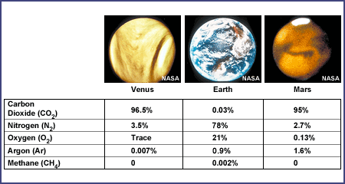
Earth has a very different type of atmosphere. Our atmosphere has much less CO₂ than Venus or Mars and our atmospheric pressure is close to midway between the two (1/90th that of Venus and 100 times that of Mars).
Many scientists believe that the composition of our atmosphere is due to the presence of life. Life acts to keep Earth's atmosphere in a dynamic balance. In other words, if life were to completely disappear, eventually our atmospheric composition could come to closely resemble Mars or Venus. Only with life continually producing oxygen through photosynthesis and removing and re-circulating CO₂ does Earth's atmosphere remain fairly stable.

Activity 1:

Using the chart on the first page, you are going to compare the chemical composition of the atmospheres of Venus, Mars and Earth. On the graphs below, assume each box is 1% of the atmosphere. Create a legend and color in the respective amounts for each gas. For partial percent’s, do your best to represent them in the boxes accordingly.

Venus Earth Mars

Legend:
Element: | Color
Carbon Dioxide
Oxygen
Nitrogen
Argon
Methane

Activity 2: Background Reading:

While we think of the atmosphere as a vast ocean of air around us, it is very thin relative to the size of the earth. The "thickness" of the atmosphere (the distance between the earth's surface and the "top" of the atmosphere) is not an exact measure. Although air is considered a fluid, it does not have the same well-defined surface as does water. The atmosphere just "fades away" into space with increasing altitude. Compared with the radius of the earth (6,370 km or 3,949 miles), the depth of the atmosphere is quite shallow.
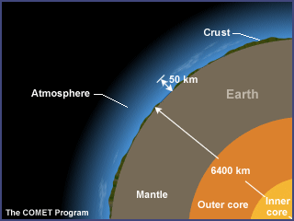
Over 99% of the mass of the earth's atmosphere is contained in two layers: the troposphere and the stratosphere. Most of the earth's atmosphere (80 to 90%) is found in the troposphere, the atmospheric layer where we live. This layer, where the earth's weather occurs, is within about 12 km (7 miles) of the earth's surface. The stratosphere goes up to about 53 km (29 miles). Gravity is the reason the atmosphere is denser, closer to the earth's surface.
This activity demonstrates the relative thickness of the thin layer that includes the troposphere and stratosphere. This layer is essential to all life on earth.
Activity 2: Scaled Atmosphere

In the box on the right, you are going to make a scale representation of the layers of the atmosphere given the following information:

Atmospheric Level | Average Altitude Range | Scaled mm Range
Troposphere | 0 – 12 km
Stratosphere | 12 – 50 km
Mesosphere | 50 – 80 km
Thermosphere | 80 – 600 km

Height of column in mm / 600 km = ___________ x thickness in km of layer = _________ thickness in mm

Use this site as a reference from this point forward, click next to advance through slides:

http://apollo.lsc.vsc.edu/classes/met130/notes/chapter1/vert_pres.html

- Draw an arrow on the side of the column showing increasing air pressure.

- Explain why air pressure changes based on altitude:

- On your diagram label where once can find:
- The ozone layer
- Weather
- Life

- Once you have drawn the layers, draw a red line showing the change in temperature as you progress from the lowest to highest altitude. Show the variances in each layer.

- One would think that temperature would decrease with altitude. Explain the changes in each level.

