Cloud Reference Sheet:

Name: Date: Period:

To form a cloud you need:
- Small solid particulates (condensation nuclei)
- Water vapor
- Air cooled to dew point or below

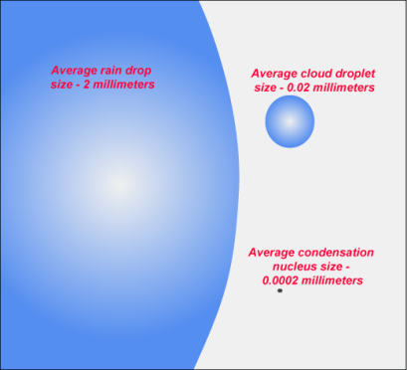

Once at the dew point, water vapor condenses on the condensation nuclei

Causes of Cooling:

Dew Point = 50°

Adiabatic Cooling Lifting Advective Cooling
Warm Air Rises, expands, and cools A mountain range or cold front Moist air travels over cold land
lifts the moist air up, cooling it or water
Cumulonimbus cloud formation

50°

Warm Air
60°
Cold Air
Fog
70°
Cold Front

^{Cooler Water}

Cloud Type | Shape | Altitude
Stratus | Flat bottomed | Low
Cumulus | Puffy, billowy | Low to Medium
Cirrus | Wispy | High

Cloud Reference Sheet:

Name: Date: Period:

To form a cloud you need:
- _____________________________
- _____________________________
- _____________________________

Causes of Cooling:

Dew Point = 50°

Adiabatic Cooling Lifting Advection Cooling

50°

60°

70°

^{Cooler Water}

Cloud Type | Shape | Altitude

- What three things are necessary to form a cloud?

- What things can make up a condensation nuceli?

- What is the difference between adiabatic and advective cooling?

- What two things do we use to classify clouds?

- What two processes of lifting lead to cloud formation? Describe both.

- If clouds are condensed water vapor, why doesn’t every cloud bring rain with it?

- How is the dew point related to cloud formation?

- At what relative humidity do clouds form?

