Continental Drift Lab:

Name: Date: Period:

Introduction:
The Earth’s crust is not a solid shell. It is made up of thick, interconnecting pieces called tectonic plates that fit together like a puzzle. They move atop the underlying mantle, a really thick layer of hot flowing rock.

By examining evidence such as similar rock layers in various places. Fossilized desert belt, the distribution of fossils, and the physical shapes of continents, scientists have concluded that the Earth’s continents were once all connected to form a “supercontinent” called Pangea that was surrounded by an enormous ocean. In this activity, students will use the different kinds of evidence to reconstruct how the Earth may have looked approximately 220 million years ago.

Procedure:
- Cut out the continents on the last page of the packet. Using their shapes and the clues provided in the legend, paste them together to form Pangea below. You might want to place them on the map and check with your teacher before you glue.
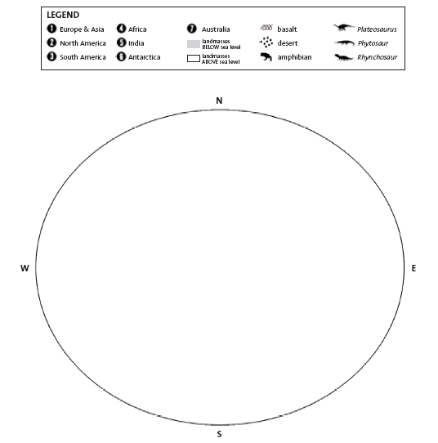

- What five kinds of evidence support Wegener’s Observation that South America was at one time joined to Africa. Be specific:
1.
2.
3.
4.
5.

- Which two continents have the most obvious fit of their coastlines:

- Where does Greenland join and what evidence supports your claim?

- How did you use Basalt rock samples as a guide in moving the continents?

- How were the fossil symbols helpful in determining where to move the continents?

- Which dinosaur is found on almost every continent:

- Since this dinosaur was incapable of swimming, how is it possible that it is found on all these different continents?

- It is generally considered that dinosaurs lived in warm climates. However, fossils are found in Antarctica, how is this possible?

- Where does Africa join Europe? What evidence supports that?

- Originally, Wegner came under fire from skeptics about his theory because the continents did not fit exactly together. Based on the fact that sonar was not available yet and the pieces you used to create Pangea, what was the missing piece of evidence that was eventually found that filled in the gaps?

- Additionally Wegner’s theory was under attack because he could not explain how the continents moved. Using your knowledge of plate tectonics and continental drift, explain how the continents moved.
CUT OUT GRAY AREAS with the Continents!!!!!
