**Determine the Epicenter of an Earthquake:**

**Name: Date: Period:**

**Introduction:**

Earthquakes occur in many places throughout the western United States, as a seismologist you do not need to have one happen under your feet to determine its location, depth, and magnitude. An earthquake dissipates part of its energy in the form of waves. They radiate in every direction from the focus point, the point in the earth where the earthquake occurs. Seismographs are devices that detect and record the time of arrival and the intensity of the different wave patterns. It only takes three (3) such seismographic recordings for the seismologist to locate the epicenter of an earthquake, which is the point on the earth’s surface directly above the focus of the earthquake.

**Part I: Determining Arrival Times:**

There are two types of waves measured by seismologists that are used to calculate the distance from their recording to the epicenter. The first wave to arrive is the P wave (primary wave), which is then followed by the S wave (secondary wave). The difference in time between the two waves tells you how far away from the epicenter you are. The longer the time between the two waves, the farther you are from the epicenter. If you can determine the time difference between the arrival of the P-wave and the arrival of the S-wave, then you can use that information to determine the distance from the epicenter using the graph below:

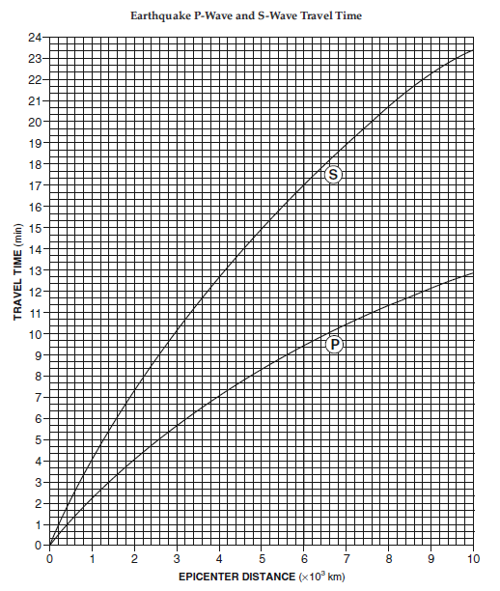



Pictured above are three seismographs from three different locations using Eastern Standard Time (EST). The first set of zig-zags represents the arrival of the P-waves, while the second set of waves are the S-waves. Using these seismographs, determine the arrival time of both waves, then determine the time difference between the two arrival times. Each unit is equal to one minute and times are given in the following format: hours:minutes:seconds. Thus 01:14:23 would represent 1:14 AM and 23 seconds. Or 21:13:56 would represent 9:13 PM and 56 seconds.

|  |  |  |  |
| --- | --- | --- | --- |
|  | First P-wave Arrival | First S-wave Arrival | S – P = time difference |
| San Jose, Costa Rica |  |  |  |
| New York, NY |  |  |  |
| San Francisco, CA |  |  |  |

1. According to this data, which station is closest to the epicenter and why?

|  |
| --- |
|  |
|  |
|  |

1. Which station is farthest away? What two pieces of evidence in the seismographs allow you to make this conclusion?

|  |
| --- |
|  |
|  |
|  |

**Part II: Determining Distance to the Epicenter:**

Now that you know the time difference between the arrival time of the two waves, you can determine the distance to the epicenter using the “Earthquake P-wave and S-wave Travel Time” graph on page one.

1. Lay strip of paper along the left side of the graph (y-axis) labeled “Travel Time (mins)”. Mark off the time difference between the two waves that you calculated for San Jose.
2. Then take that sheet of paper and slide it until the two marks lie exactly on both curves as seen below:



1. Trace down to directly below to the x-axis labeled (epicenter distance) to determine the distance from the station to the epicenter. In the example above you see that this station is 5,000 km (5x103 km) from the epicenter.

|  |  |
| --- | --- |
| Seismograph Location | Distance to Epicenter |
| San Jose, Costa Rica | Kilometers |
| New York, NY | Kilometers |
| San Francisco, CA | Kilometers |

**Part III: Determining Location of the Epicenter:**

Once one knows the distance to the epicenter from three different points, one can determine the approximate location of the epicenter of the earthquake. In this first example, we are going to use the information gathered in Part II.

1. Using the scale on the bottom of the map on the next page, open your compass so that it is equal to the distance calculated in part two, with the sharp pointy end anchored on 0. You may have a distance that is longer than the scale, in which case open your compass to the full 3,000 km, then pick it up and place it so the pencil end is on the 0, then open it until you reach the distance needed.
2. Once your compass is open to the correct distance, place the sharp pointy end on the city where the station was located and very carefully and accurately, create a full circle.
3. Repeat the procedure for the other sites.
4. The point where all three circles intersect is the epicenter of your earthquake.



**Part V: Practice Set #1**

Using the skills you have just practiced, determine the epicenter of each earthquake:

Orlando:

|  |  |  |  |  |
| --- | --- | --- | --- | --- |
|  |  |  |  |  |

12:13 AM 12:14 AM 12:15 AM 12:16 AM

Kansas City:

|  |  |  |  |  |
| --- | --- | --- | --- | --- |
|  |  |  |  |  |

12:11 AM 12:12 AM 12:13 AM 12:14 AM

Los Angeles:

|  |  |  |  |  |
| --- | --- | --- | --- | --- |
|  |  |  |  |  |

12:17 AM 12:18 AM 12:19 AM 12:20 AM

|  |  |  |  |
| --- | --- | --- | --- |
|  | First P-wave Arrival | First S-wave Arrival | S – P = time difference |
| Orlando, FL |  |  |  |
| Kansas City, MO |  |  |  |
| Los Angeles, CA |  |  |  |

|  |  |
| --- | --- |
| Seismograph Location | Distance to Epicenter |
| Orlando, FL | Kilometers |
| Kansas City, MO | Kilometers |
| Los Angeles, CA | Kilometers |

1. According to this data, which station is closest to the epicenter and why?

|  |
| --- |
|  |
|  |
|  |

1. Which station is farthest away? What two pieces of evidence in the seismographs allow you to make this conclusion?

|  |
| --- |
|  |
|  |
|  |

1. Find the epicenter using a compass and the map on the last page.

**Part IV: Practice Set #2**

San Francisco, CA:

|  |  |  |  |  |  |  |  |
| --- | --- | --- | --- | --- | --- | --- | --- |
|  |  |  |  |  |  |  |  |

1:30 PM 1:31 PM 1:32 PM 1:33 PM 1:34 PM 1:35 PM 1:36 PM

Oklahoma City, OK:

|  |  |  |  |  |  |  |  |
| --- | --- | --- | --- | --- | --- | --- | --- |
|  |  |  |  |  |  |  |  |

1:39 PM 1:40 PM 1:41 PM 1:42 PM 1:43 PM 1:44 PM 1:45 PM

Cheyenne, WY:

|  |  |  |  |  |  |  |  |
| --- | --- | --- | --- | --- | --- | --- | --- |
|  |  |  |  |  |  |  |  |

1:32 PM 1:33 PM 1:34 PM 1:35 PM 1:36 PM 1:37 PM 1:38 PM

|  |  |  |  |
| --- | --- | --- | --- |
|  | First P-wave Arrival | First S-wave Arrival | S – P = time difference |
| San Francisco, CA |  |  |  |
| Oklahoma City, OK |  |  |  |
| Cheyenne, WY |  |  |  |

|  |  |
| --- | --- |
| Seismograph Location | Distance to Epicenter |
| San Francisco, CA | Kilometers |
| Oklahoma City, OK | Kilometers |
| Cheyenne, WY | Kilometers |

1. According to this data, which station is closest to the epicenter and why?

|  |
| --- |
|  |
|  |
|  |

1. Which station is farthest away? What two pieces of evidence in the seismographs allow you to make this conclusion?

|  |
| --- |
|  |
|  |
|  |

1. Find the epicenter using a compass and the map on the last page.

