Earth Science Diagram Review:

Name: Date: Period:

- On the diagram of the Earth’s layer below, complete the following tasks:
  - Label each layer
  - Next to each layer – put its phase (solid, liquid, gas)
  - Draw convection happening in the appropriate layer
  - Draw an arrow and label it increasing temperature
  - Draw an arrow and label it increasing density

- Explain the density differences using the terms mass and volume below:

- Which of the following rocks will erode faster and why:
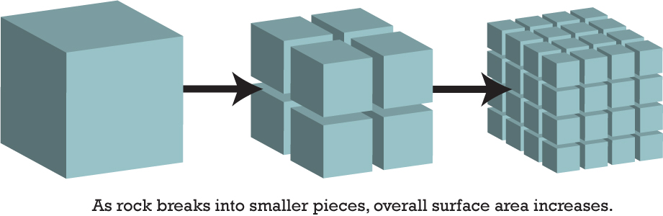

- On the diagram below complete the following tasks:
  - Label where new crust is forming
  - Label where old crust is being destroyed
  - Label where we would find the youngest crust
  - Label where we would find the oldest crust
  - Label the subduction zone
  - Label where sea floor spreading is occuring
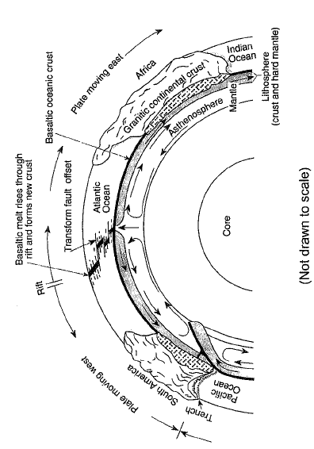
  - Describe what is happening to the size of the Atlantic Ocean and why?

  - Describe the age of the crust as you go from South America to Africa? Be sure to explain your statement:

  - On your diagram, the Pacific Plate is subducting under South America explain why this is occurring:

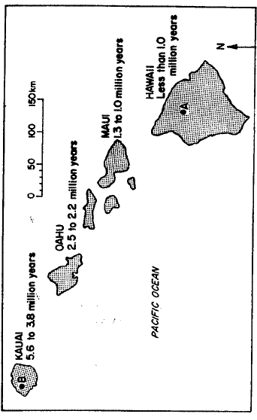
- Answer the following questions based on the diagram above:
  - If A is the hot spot, describe the age of the islands relative to each other:

  - In which direction is the Pacific plate moving? Explain:

  - Where will the next island in the Hawaiian island arc most likely form. Explain:

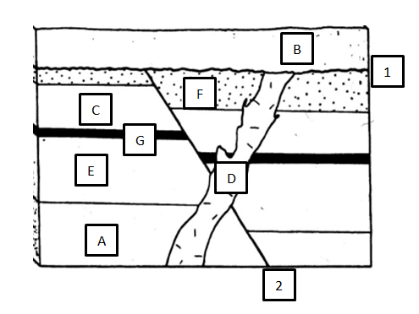
- Using the diagram above, answer the following questions:
  - List the layers and events in order of oldest to youngest. Explain your reasoning using 3-4 principles that we have learned about:

- If a radioactive dating isotope has a half-life of 8 hours. How long will it take for a 384g sample to radioactively decay to 3g? Show your work and graph below:

- Answer the following questions based on the diagram below:
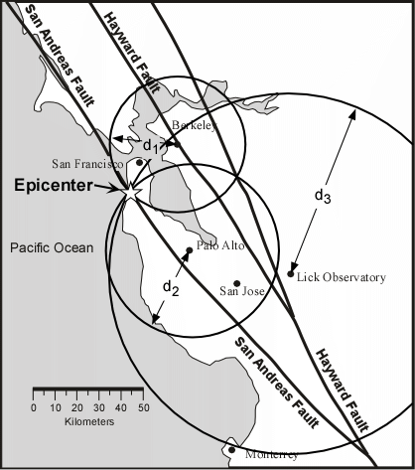
  - At all three stations, which type of wave reached them first and why? On the complete opposite side of the world, what would that station read and why?

  - Which station would have the smallest time difference between arrival times? Which one would have the largest? Why?

  - If you didn’t have the Lick Observatory readings, could you pinpoint the epicenter? Why or why not?

