Geologic Time Scale Lab:

Name: Date: Period:

Introduction:

The Earth has changed dramatically and repeatedly over a history that spans nearly five billion years. Such immense spans of time are difficult for most of us to comprehend. They fall outside our range of human experience. We normally deal with much shorter time intervals, like the time of our next class or the number of days until the next test, or even the number of years until graduation!

It is important for students of geology to expand their sense of time. Extremely slow geologic processes, considered only in terms of human experience, have little meaning. To appreciate the magnitude of geologic time and the history of our incredible planet, you will be creating a timeline of important geologic events scaled to a size more tangible and familiar.

Pre-Lab Questions:

- How many millions are there in a billion?

- In lab, you will make a timeline 4.56 meters long to represent the 4.56 billion years of Earth’s history:
- How long would 1 billion years be on the timeline?

- How many years would 100 cm represent?

- How many years would 1 cm represent?

- Draw a line that is 1 cm long.

Procedure:

You will be making a timeline of Earth’s history on a long strip of adding machine tape. The timeline should be done to scale. A scaled representation requires that 10 cm on your timeline represent the same amount of time anywhere along the timeline and each amount of time, say 5 million years, be represented by the same distance throughout the timeline.

To do this you will:
- Measure out a strip of adding machine tape 4.56 meters long. A meter stick will be provided in lab. (Using the metric system is hard, however, using feet and inches makes this lab nearly impossible)

- Go to the right end of the tape to represent the Present. Beginning at that end, mark off each billion years ago (1 billion years ago, 2 billion years ago, etc.) at the very bottom of the adding machine tape (See Figure 3 as an example)

- At the top of the adding tape, denote the beginning and end of each of the four eras using Figure 1 below.

- Using the chart below and starting with the oldest event (Event #1), mark off all of the important events in Earth’s history shown in Figure 2 in the middle of the ticker tape. Extend an arrow to the exact place on the time line to the bottom of the ticker tape. In each case you should write the date and event directly on the timeline above.

Figure 1:
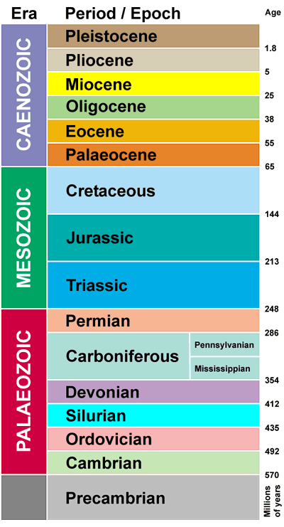

Figure 2:
Some Important Events in Earth’s History
Event # | Date in years before present | Event
1 | 4.56 billion | Earth forms
2 | 4.4 billion | Oldest mineral grain found
3 | 4.1 billion | Oldest piece of rock ever found
4 | 3.9 billion | Oldest evidence of a continent
5 | 3.8 billion | First evidence of life
6 | 3.5 billion | First fossils (algae and bacteria)
7 | 1.8 billion | Free oxygen in atmosphere
8 | 1.1 billion | First fossil of a complex organism (a worm)
9 | 540 million | First abundant life found in the rock record
10 | 460 million | First fish
11 | 440 million | First land plants
12 | 410 million | First land animals
13 | 250 million | Largest mass extinction occurs
14 | 247 million | First dinosaurs
15 | 240 million | First mammals
16 | 220 million | Breakup of super-continent Pangaea begins
17 | 145 million | First flowering plants
18 | 65 million | Dinosaurs and other animals go extinct
19 | 30 million | Mammals/flowering plants become abundant
20 | 5 million | Beginning of Cascade Volcanic Arc
21 | 1.8 million | First primate in genus Homo
22 | 40,000 | First Homo sapiens
23 | 13,000 | Humans first inhabit North America
24 | 10,000 | End of last Ice Age
25 | 8,000 | Founding of Jericho, the first known city
26 | 2,000 | Roman domination of the world
27 | 500 | European rediscovery of the Americas
28 | ~34 | Humans first explore the moon

Figure 3:
Precambrian Era

First Fossil of a Complex Organism
1.1 Billion Years Ago

1 Billion Years Ago

Analysis Question:

- In the end, you found that the following amounts were represented by what length:

  - One million years = __________________________________

  - One thousand years = _________________________________

  - One hundred years = __________________________________

  - One year = _________________________________

- Name the 4 eras of geologic time in order from oldest to most recent. Then, indicate
the time span of each era to the right of that era. Some have been started for you.

__Precambrian_____ Era = ____________ years ago to ____________ years ago

____________________ Era = ____________ years ago to ____________ years ago

____________________ Era = ____________ years ago to ____________ years ago

____________________ Era = ____________ years ago to present day

- What era began 65 cm from today on our time line?

- How old is the Earth?

- How long have humans existed? Put that in a fraction then calculate the percentage of time that humans have existed during the history of the Earth?

- During which era did Pangaea begin to break up?

- How long was the Precambrian time period? What percentage of the Earth’s History did it make up?

