Heat in the Atmosphere Review Questions:

Name: Date: Period:

- Cite specific examples from the lab where conduction, convection and radiation were present and how they were shown.

- What type of things can diminish the Greenhouse effect and why? What type of things can enhance the Greenhouse effect and why?

- Why are we having summer when we are farther from the sun than we are in winter?

- Describe how Station 10 in the lab demonstrated why more direct sunlight will lead to summer versus indirect sunlight?

- Use the idea of albedo to describe why it is cooler on a cloudy day than a sunny day.

- The diagram below shows land and sea breezes:
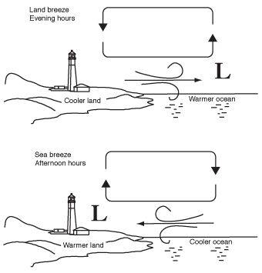
- In the sea breeze diagram. Identify where we will see the three types of heat transfers:

- The following data was obtained from running an experiment similar to Station 13. Based on this data, what inferences or conclusions can you make? Graph the data below:

Light on
 | Mins | Land Temp | Water Temp
 | 0 | 20 | 20
 | 15 | 25 | 22
 | 30 | 30 | 24  Light off
 | 45 | 35 | 26
 | 60 | 30 | 24
 | 75 | 25 | 22
 | 90 | 20 | 20

