**Introduction to Interpreting Earth’s History:**

**Name: Date: Period:**

**Background Reading:**

Until recently, there was no way to determine how old the rock units actually were. Thus determining the age of rocks was done using relativity. For instance, dinosaurs came and went before large mammals. This can be determined by studying the relationships between rock units. Worldwide, rock units that bear dinosaur bones are underneath those that bear mammal bones. According to the **principle of superposition**, they must be older. Thus, a geologist finding two widely separated rock units, one containing mammal bones and one containing dinosaur bones knows that the unit with dinosaurs is older than the one with the mammals. This is called **relative dating.** It wasn’t until the discovery of radioactivity in rocks that geologists were able to give rocks **absolute ages** (for example: dinosaurs went extinct 66 million years ago). Relative dating is cheaper and easier and so is regularly used by geologists for most purposes. Additionally, it is assumed by scientists that the same scientific and geologic processes that are occurring now were the same processes that were occurring in the past. This principle is called **uniformitarianism**.

**Background Questions:**

Based on the reading, define the following terms:

Superposition:

Uniformitarianism:

Relative Dating:

Absolute Dating:

**Model #1:**

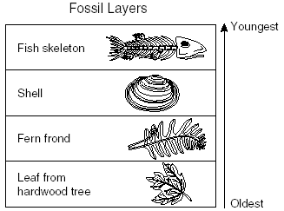Based on the above information, list the following fossils in order from oldest to youngest:

Oldest:_____________________________

Less Old:____________________________

Younger:____________________________

Youngest:___________________________

**Model #2:**

**Principle of original horizontality**: When sedimentary rock layers are being deposited, gravity forces them to be deposited as flat, horizontal layers. Once the sediment has solidified and become rock, they can be tilted or folded.

Based on this new bit of information, along with the previous mentioned principles, and the diagram below, answer the following questions:

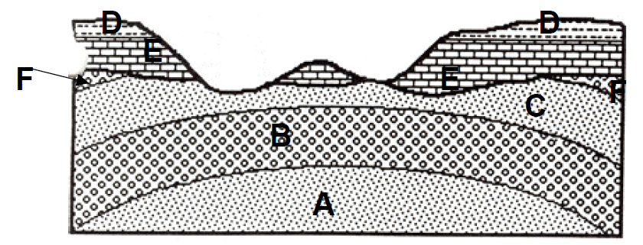

List the layers in order from oldest to youngest:

|  |  |  |  |  |  |
| --- | --- | --- | --- | --- | --- |
|  |  |  |  |  |  |

What could account for layers A, B, C and F being folded? Were they always like that or were they changed after they were deposited?

|  |
| --- |
|  |
|  |
|  |

What accounts for the damage done to rock layers C, D, E, and F?

|  |
| --- |
|  |

Place the following events in historical order:

1. Layers D, & E deposited:________
2. Massive erosion:________
3. Layers A, B, C, & F deposited:_______
4. Folding and faulting:________

**Model #3:**

**Principle of crosscutting relationships:** An igneous rock unit or fault that cuts across another rock unit must be younger than the unit it cuts across. In other words, the other rock unit must have already been there for the igneous rock or fault to cut across it.

**Metamorphic rocks:** A metamorphic rock is always older than the non-metamorphosed rocks around it. The metamorphic rock must have formed before the surrounding rocks, otherwise they would be metamorphosed as well (show contact metamorphism).

Based on the information above, previously mentioned information, and the diagrams below, answer the following questions:

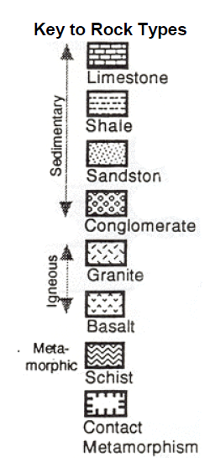

F

E

D

C

B

A

List the rock layers in order that they were deposited or were created:

|  |  |  |  |  |  |
| --- | --- | --- | --- | --- | --- |
|  |  |  |  |  |  |

When did the three episodes of erosion happen:

|  |  |
| --- | --- |
| 1st |  |
| 2nd |  |
| 3rd |  |

Why did the igneous rock (rock layer A) have an effect on rock layer B (contact metamorphism) but not rock layer D?

|  |
| --- |
|  |
|  |
|  |

**Model #4:**



E

List the rock layers in order from oldest to youngest:

B

D

What explains the disjointed layers of A and C?

C

A

**Model #5:**



Label the rock layers 1-13, in order from oldest to youngest:

Write a history of these rock layers below:

Ex: 1. Rock layers 1-3 deposited

2. Erosion

3. Rock layers 4-5 deposited

4. Igneous intrusion

5. Erosion

|  |
| --- |
|  |
|  |
|  |
|  |
|  |
|  |
|  |
|  |
|  |
|  |
|  |
|  |
|  |
|  |
|  |