Relative Dating Model: Making Your Own

Name: Date: Period:

Objective:

By the end of class, students will demonstrate their knowledge of relative dating by creating their own block diagram.

Procedure:

- You are going to create your own relative dating model. You will need to include the following:
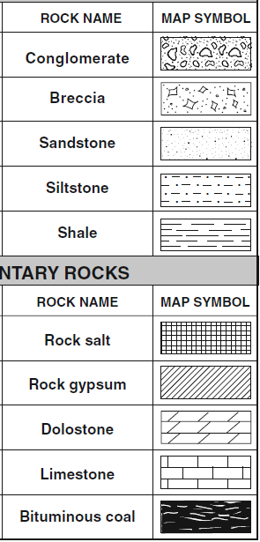
- At least 6-8 layers of rock (types of rock can be used twice). Use the symbols to the right for your sedimentary layers. Use “x’s” for your igneous rock symbol and dashes perpendicular to it for any contact metamorphism.
- One faults
- Folded layers and/or tilted layers
- At least one intrusion
- Two time periods of erosion
- Inclusions
- All discussed laws and principles

- It might be helpful to create a couple rough drafts on a separate sheet of paper before you commit to the final draft

- When you do your final, be sure to use rulers if needed and strive for accuracy.

- Label rock layers with letters and unconformities (erosion, intrusions, faults) with numbers. But be careful not to put the letters or numbers in order of age.

- Once you are done your model, you will need to create a script for what happened in the correct order in the space below it.

- Be sure to identify the following laws and principles on your diagram and explain what they are and how they are seen in your diagram:
- Law of Superposition
- Law of Cross Cutting Relations
- Law of Inclusions
- Principle of Original Horizontality

