Mapping the Ring of Fire:

Name: Date: Period:

Objective: By the end of the lab period, students will be able to identify the Ring of Fire/Pacific Rim using data from earthquakes and volcanoes

Mapping the Ring of Fire (Part 1):

- Using a yellow pencil on a map of the world make a prediction and shade the areas where you think the most earthquakes occur.
- Using an orange pencil on a map of the world make a prediction and shade the areas where you think the most volcanoes occur.
- Label each of the following in brown (use computer if necessary):
  - North America continent
  - South America continent
  - Australia continent
  - Asia continent
  - Pacific Ocean
  - Sea of Japan
  - Mt Rainier
  - Mt Fuji
- Outline and Label the following in green:
  - United States of America
  - Japan
- Use the information in the data table below to mark the location of each earthquake and volcano on the world map that follows the data table. Use a blue colored pencil to draw a circle at each earthquake location.
- Use a purple colored pencil to mark the locations of the volcanoes on the map with a triangle.

Earthquakes Volcanoes
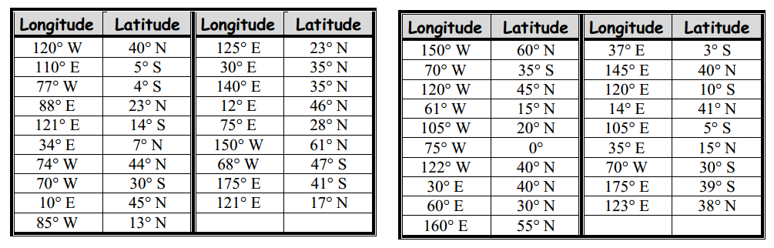

Mapping the Ring of Fire (part 2):
- View a map of seismic data from the Pacific Northwest.
- After viewing the data make inferences and sketch the plate boundaries in the Pacific Northwest with a red pencil.
- View a map of seismic data from Southeast Asia.
- After viewing the data make inferences and sketch the plate boundaries in Southeast Asia with a red pencil.
- View a map of seismic data from the Pacific Rim.
- After viewing the data make inferences and sketch the plate boundaries with a red pencil.
- After you have sketched your inferred boundaries compare your map to a map of the plates of the Pacific Rim
- Draw in and label the following plate tectonic structures in black:
- North American Plate
- Pacific Plate
- East Pacific Rise
- Juan de Fuca Plate
- Aleutian Trench
- Philippine Plate
- Cocos Plate
- Nazca Plate
- Eurasian Plate
- Japan Trench
- Australian Plate
- Marianas Trench
- Peruvian (Atacama) Trench
Analysis and Conclusion Questions:
- View a map of seismic activity of the Pacific Northwest What pattern do you see? What does this pattern mean?

- View a map of seismic activity of Southeast Asia. What pattern do you see? What does this pattern mean?

- Analyze your map. How many plates lie under the Pacific Ocean?

- Are all plates the same size?

- How many plates interact near the Washington?

- How many plates interact near Japan? Which ones?

- Explain how earthquakes can be used to infer plate boundaries.

- Where are the majority of volcanoes found in the Pacific Rim? (Are they found in the middle of the plates or on the edges?)

- Are volcanoes found everywhere earthquakes are found? Explain.
