**Relative Dating Diagrams:**

**Name: Date: Period:**

**In your lab groups work together to determine the relative ages of the following diagrams. Sometimes they include letters and numbers in which the numbers are the rock layers and the numbers are events (faults, etc.)**

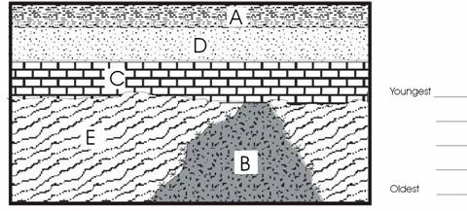

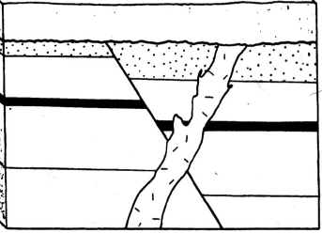

A

C

E

G

F

B

D

