Relative Humidity Lab:

Name: Date: Period:

Background Reading:

Humidity is the amount of moisture in the air. How do we know how much moisture the air can hold? Think about what time of year you experience the most humidity and what time of year when your skin feels dry and ashy. Absolute humidity measures how much water vapor is in the air per cubic meter. Relative humidity measures the amount of water vapor that is currently in the air compared to how much the air can hold at that temperature. To find relative humidity:

____________________Water vapor in the air___________________ x100
Max amount of water vapor the air can hold at that temperature

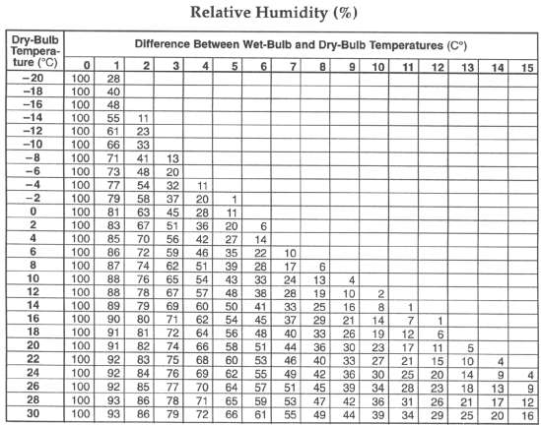
In your Reference Tables for Earth Science, you can find the relative humidity chart. To find the relative humidity, you must first calculate the difference between the wet-bulb and the dry-bulb temperatures. Then find on the table the point where the dry-bulb temperature and the difference between the two temperatures intersect. The number at this intersection is the percent relative humidity

Example: Find the relative humidity if the dry-bulb temperature is 10 degrees Celsius and the web bulb temperature is 5 degrees Celsius:

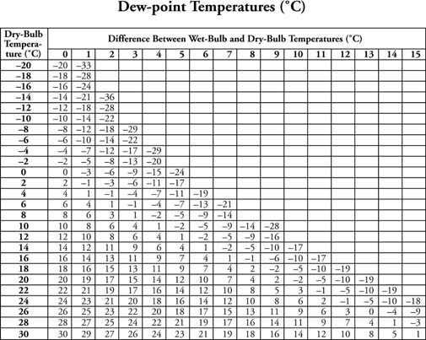
To find the relative humidity you need the dry-bulb temperature and the difference between the dry-bulb and wet bulb temperatures. The dry-bulb temperature is given as 10 degrees Celsius. The difference between the dry-bulb and the wet-bulb temperatures must be calculated. It is 10-5=5 degrees Celsius. The number on the table where these two temperatures intersect is 43. The relative humidity is 43%

The dew point is the temperature at which the water vapor in the air will begin to condense into liquid water. This is the temperature at which the amount of water vapor currently in the air equals the equilibrium amount of water vapor. To find the Dew Point using the chart in your Reference Tables for Earth Science you do the same thing as for Relative Humidity. Example: Find the dew point based on the

Procedure:
- Attach a 1” piece of muslin around the bulb of one of the two glass thermometers. This will serve as your wet-bulb. The other thermometer will serve as your dry-bulb.
- Soak the muslin with enough pure distilled water so that it is not dripping wet.
- Carefully whirl the two thermometers in the air for about 30 seconds, or until the wet-bulb temperature stops falling and remains constant.
- Read and record the temperature of the dry bulb and the wet bulb.
- Record the difference in temperature of the Dry-Bulb - Wet Bulb
- On the Dew Point Chart, find the dry-bulb temperature along the left column.
- Next find the difference between Dry-Bulb and Wet-Bulb Temperatures along the top row of the Dew Point chart
- Follow the row containing the dry-bulb temperature until you reach the intersection of the column containing the dry-bulb and wet-bulb difference. This is your dew point.
- Record the Dew Point on your chart
- On the Relative Humidity Chart, find the dry-bulb temperature along the left column.
- Next, find the difference between Dry-Bulb and Wet-Bulb Temperatures along the top row of the Relative Humidity chart.
- Follow the row containing the dry-bulb temperature until you reach the intersection of the column containing the dry-bulb and wet-bulb difference. This is your relative humidity.

Data Table 1
Dry-Bulb Reading | Wet-Bulb Reading | Dry-Bulb - Wet Bulb (Difference in Temperature) | Dew Point  from Dew Point chart | Relative Humidity  from Relative Humidity chart
______°C | ______°C | ________°C | _______°C | ______%

Practice Problems:
Directions: Use the information below, and your Earth Science Reference Tables to fill in the blanks below. You may need to use the completed table to figure out the answers to the conclusion questions at the end of the lab.

1. Dry Temperature 12 6. Dry Temperature ____
Wet Temp 10 Wet Temp ____
Difference ____ Difference 5
Dew Point ____ Dew Point 4
Relative Humidity ____ Relative Humidity ____

2. Dry Temperature 22 7. Dry Temperature ____
Wet Temp 15 Wet Temp ____
Difference ____ Difference 7
Dew Point ____ Dew Point ____
Relative Humidity ____ Relative Humidity 40

3. Dry Temperature 0 8. Dry Temperature ____
Wet Temp ____ Wet Temp 16
Difference 2 Difference 4
Dew Point ____ Dew Point ____
Relative Humidity ____ Relative Humidity ____

4. Dry Temperature -4 9. Dry Temperature 18
Wet Temp -8 Wet Temp 18
Difference ____ Difference ____
Dew Point ____ Dew Point ____
Relative Humidity ____ Relative Humidity ____

5. Dry Temperature 4 10. Dry Temperature ____
Wet Temp 0 Wet Temp ____
Difference ____ Difference ____
Dew Point ____ Dew Point 8
Relative Humidity ____ Relative Humidity 40

11. Look at data table 2. There are two variables in Data Table 2 below. What are
they?________________________ and ______________________
12. The independent variable is ____________________ and goes on the _______ axis. The dependent variable is ________________________ and goes on the ______ axis.
13. Label each axis on your graph paper. Don’t forget the units!
- Using Data Table 2, plot each point on the graph
- Connect each point with a smooth curve.
- Label the graph with an appropriate title. Hint: The title should convey what is being shown on the graph
- Answer the conclusion questions in complete sentences.

Data Table 2:

Temperature in Celsius | Max Amount of water vapor per cubic meter of air (grams)
0 | 5
5 | 7
10 | 10
15 | 12
20 | 15
25 | 22
30 | 30
35 | 35
40 | 50
45 | 65
50 | 80

Conclusion Questions, answer in complete sentences:
- Based on your graph, if air at 50 degrees Celsius holds 80 grams of water vapor, it is said to be __________________. What is the relative humidity? Show your work.

- Based on your graph, if a cubic meter of air at 28 degrees Celsius holds 14 grams of water vapor, what is its relative humidity? Show your work.

- Based on your graph, if a cubic meter of air at 17 degrees Celsius holds 10 grams of water vapor, what is its relative humidity? Show your work.

- Based on your graph, if a cubic meter of air holds 50 grams of water vapor its temperature cannot be below ______________.

- What is the dew point? What can be said about air which is at its dew point?

- What is the difference between (absolute) humidity and relative humidity?

7. What factors affect or determine the relative humidity of the air?

8. Determine the Dewpoint Temperature and the Relative Humidity of air when:
a. Dry Bulb = 20ºC Dew Point ________
Wet Bulb = 12ºC Relative Humidity ________

b. Dry Bulb = 10ºC Dew Point ________
Wet Bulb = 7ºC Relative Humidity ________

9. If all other factors remain unchanged, what happens to the relative humidity of an air mass when the temperature rises? Explain.

10. If all other factors remain unchanged, what happened to the relative humidity of an air mass as more water evaporates into the air? Explain.

11. Imagine an air mass, temperature 12ºC, Dewpoint 8ºC. What is the relative humidity of that air mass? Explain how you got that answer.

