Relative Humidity Literacy Prompt:

Name: Date: Period:
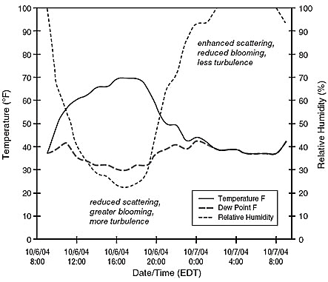
Analyze the graph seen to the right. In the space below, create a chart that analyzes temperature (°F), dew point (°F), and relative humidity (%) every four hours beginning with 12:00, 10/6/04. Then on the lines below, describe the relationship between temperature, dew point, and relative humidity citing specific data points from your chart and the graph.

