**Sedimentary Rock Identification Lab:**

**Name: Date: Period:**

**Introduction:**

As you now know, rocks are composed of minerals or a combination of minerals. Rocks are categorized into types based on the way in which they form. Sedimentary rocks form as weathered, eroded and deposited materials are compacted and cemented together beneath the weight of overlying sediments. Sedimentary rocks are classified into three major categories based on their composition- **CLASTIC,** or fragmental (derived from weathering and erosion of land materials), **CRYSTALLINE** (form from precipitation of dissolved salts in sea water) and **BIOCLASTIC** (fragments of living organisms). The clastic sedimentary rocks are identified and named by **grain size**, while the others are identified by **composition**. These characteristics, in turn, signify a particular **environment of formation**. As you know from our study of igneous rocks, **if you know the rock, you know the past environment!** Using your senses and the **Scheme for Sedimentary Rock Identification**, you will be able to first classify and identify the rocks and their environments of formation.

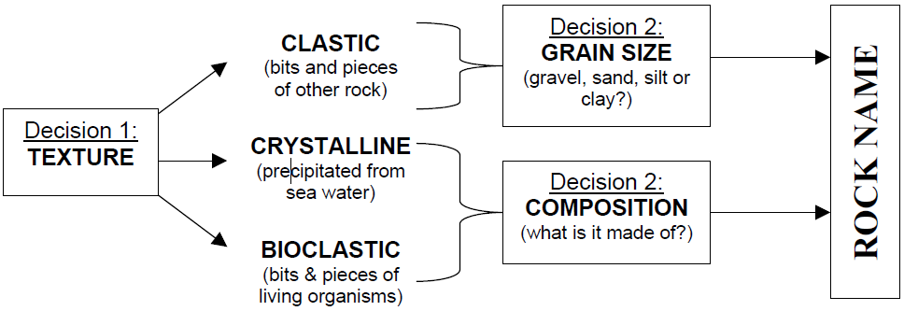

**Procedure:**

1. Fill-in the data table with a description of the rock, try to decipher the rock name by looking at the rock, descriptions and ESRT and finally determine what type of sedimentary rock it is: CLASTIC, CHEMICAL, or ORGANIC.
2. Read the exploration questions carefully.
3. Use your ESRT to help explore for the answers to the questions.
4. Hand in completed lab for grading.

|  |  |  |  |
| --- | --- | --- | --- |
| **Rock Number** | **Description of rock** | **Rock Name** | **Type of sedimentary rock (clastic, chemical or organic)** |
| 13 |  |  |  |
| 14 |  |  |  |
| 15 |  |  |  |
| 16 |  |  |  |
| 17 |  |  |  |
| 18 |  |  |  |
| 19 |  |  |  |
| 20 |  |  |  |
| 21 |  |  |  |
| 22 |  |  |  |
| 23 |  |  |  |
| 24 |  |  |  |

**Exploration Questions:**

1. Very fine grained clastic rock made mostly of quartz, feldspar and clay. _____________________
2. Rock salt, rock gypsum and dolostone are all which type of sedimentary rock. ______________
3. This is the sedimentary rock that caves are formed in. _________________________
4. Sedimentary rock formed from prehistoric plants.______________________________
5. Sedimentary rock made from the smallest sized particles. ____________________________
6. Fine to course clastic rock made mostly of quartz.__________________________________
7. Sedimentary rock made of sharp angled sediment of various sizes.________________________
8. Name of the two organic sedimentary rocks listed within the table. ___________________________
9. What is the main difference between a conglomerate and a breccia?

________________________________________________________________________

1. What is lithification? _________________________________________________________________________
2. What is type of sedimentary rock is an evaporite? _________________________

**Rock Names and Descriptions:**

* **ARGILLACEOUS (CLAYEY) SANDSTONE.** This rock contains fine sand and clay that has been consolidated. It is often used as a flagstone.
* **ARGILLACEOUS SHALE.** This is a solidified clay.
* **BITUMINOUS SHALE.** Black shales separate many coal beds. Fossilized plant remains are often present.
* **CHERT.** Chert is a dense, extremely fine crystalline (cryptocrystalline) rock composed of chemically-precipitated silica.
* **COQUINA.** This rock is formed by the accumulation of shells and shell fragments (fossil debris) composed of calcium carbonate.
* **DOLOMITIC LIMESTONE.** Many limestones will "fizz" when a drop of dilute acid is placed on the surface, but this one will not because it is composed of the mineral "Dolomite."
* **GYPSUM.** This rock is so soft that it can be scratched with one's fingernail. It is composed of the mineral Gypsum, and it is used in the manufacture of plaster.
* **QUARTZ CONGLOMERATE.** This is a typical conglomerate and is composed of quartz gravel and quartz sand that has been cemented by natural silica to form rock.
* **RED SANDSTONE.** This is consolidated sand. Its color (due to iron in the cementing material) makes it an attractive building stone.
* **SHELL LIMESTONE.** This rock is composed of very many fossil shells.
* **SILTSTONE.** A thinly bedded clastic rock containing abundant silt size grains, commonly quartz.
* **TRAVERTINE.** Water dripping from the roofs of caves forms icicle-shaped stalactites. Similarly, water from springs will deposit a lime. These deposits are known as Travertine.