The Future of the Atlantic:

Name: Date: Period:

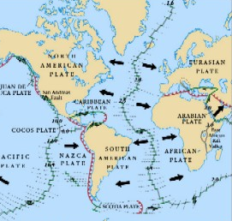

The above diagram shows the movement of tectonic plates in the Atlantic Ocean. In the space below describe how the Atlantic Ocean will change over the next couple hundred million years. In your answer be sure to talk about:
- Mid Ocean Ridges
- Sea Floor Spreading
- Convection Currents
- Plate Tectonics
- The age of sea floor as you go from the Western Hemisphere (North America and South America) to the Eastern Hemisphere (Europe and Africa)

