Theory of Plate Tectonics CD Rom Activity:

Name: Date: Period:

Logging into the Program:

Log into the computer > Go the “Hand Out” folder > “MONGANO” > “Launch” > Click Mouse

From Main Menu, click on #2 Continental Drift, Use Forward and Reverse to Navigate

2. Continental Drift:
1. What are the four pieces of evidence used by Wegener?

2. What two continents had the best fit?

3. What three ideas were suggested for the wide spread fossil distribution?

4. On your model of Pangea and current map, draw and label the distribution of the four fossils? (Use hand to drag continents back and forth)
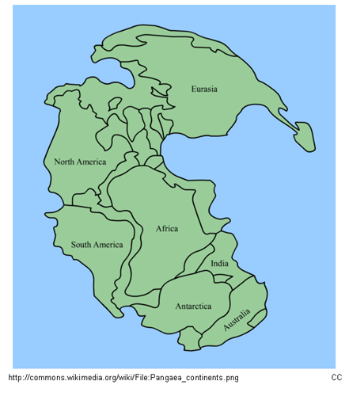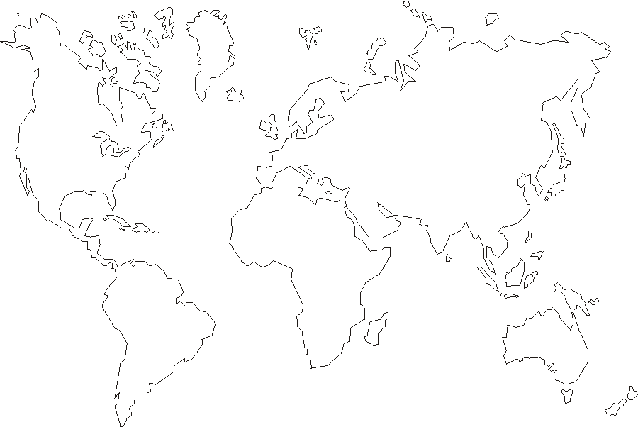
5. The Appalachian Mountains used to stretch into what other geographic region?

6. How are climatic clues used to show existence of Pangea?
7. What was Wegener wrong about in regards to Continental Drift?

8. Answer the Review Questions, but do not print or save the file.

3. Exploring Continental Drift:

9. Work your way through the Exploring Continental Drift

4. Earth’s Interior:

10. How hot is the interior of the Earth?

11. Fill in the following chart:
Layer: | Solid/Liquid: | Made of: | Diameter/Thickness:

12. Compare and contrast oceanic and continental crust (thickness, density, composition):

13. What is the differences between the lithosphere and asthenosphere?

14. Answer the Review Section but do not print or serve.

5. New Evidence: Mapping the Ocean Floor

15. Work your way through this section

6. Plate Tectonics: A Scientific Revolution Unfolds

16. What are the seven largest plates:
17. What are the three types of plate boundaries:

18. Diagram the Juan de Fuca plate, including labeling movement and types of boundaries:

19. Answer the review questions but do not print or save.

7. Divergent Plate Boundaries:

20. What is the range of rates for seafloor spreading:

21. What is continental rifting:

22. What is a rift valley:

23. If you look at the rifting in East Africa, what will happen to the land east of Lake Victoria:

24. Answer the review questions, but do not print or save.

8. Convergent Plate Boundaries:

25. Where do convergent boundaries occur:

26. What is a subduction zone:

27. What happens when oceanic and continental crust collide:

28. What happens when crust reaches 100 km in depth:

29. What happens when two pieces of oceanic crust collide:

30. Where are most of the volcanic island arcs found:

31. What happens when two pieces of continental crust collide:

9. Transform Boundaries:

32. What happens at a transform fault:

33. What will supposedly happen to Western California over the next million years:

Closer Look at Plate Tectonics:

Go through all the review questions as a review as they will be “similar” to questions on your test

