Weather Front and Air Mass Webquest:

Name: Date: Period:

Go to the following website for links for questions:
http://poster.4teachers.org/worksheet/view.php?ID=94053
Site 1
1. What is an air mass?

2. Where do polar and tropical air masses develop? (Give the approximate latitudes.)

3. For each of the four air masses, what is the description this website gives?
Air Mass | Description

Site 2
4. Why is the United States not a great place for air masses to form?

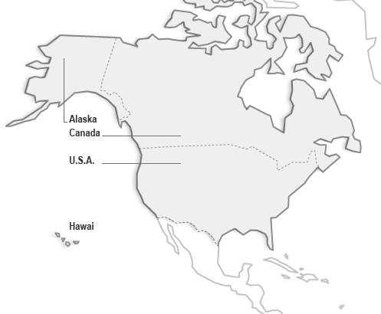
Site 3
5. This site describes five basic types of air masses. At site one you only learned about four types. Write the name of the “new” air mass and give two important facts about it.

6. Label the air masses on the map with the appropriate abbreviation.
Site 4
7. In the first illustration, what kind of air mass is passing over the region? What type of weather will it bring?

8. In the second illustration, what kind of air mass is passing over southern California? What type of weather will it bring?

Site 5
9. Click on the “Cold Front.” What happens in the illustration?

10. Click on the “Warm Front.” What happens in the illustration?

11. In both the cold front and the warm front, warm air rises and cold air stays near Earth’s surface. How are they different?

Site 6
12. What is a cold front and in what direction does one typically move?

13. How are cold fronts represented on a weather map?

14. From the chart at the bottom of the page, what happens to the wind as a cold front passes through? What about the precipitation?

Site 7
15. What is a warm front and in what direction does one typically move?

16. How are warm fronts represented on a weather map?

17. From the chart at the bottom of the page, when a warm front passes through an area, what happens to the temperature and precipitation levels in that area?

Site 8
18. What is a stationary front and what type of weather does one typically bring?

19. What is the weather map symbol for a stationary front?

Site 9
20. How does an occluded front form?

21. What is the weather map symbol for an occluded front?

