Weather Systems Writing Prompt:
Name: Date; Period:
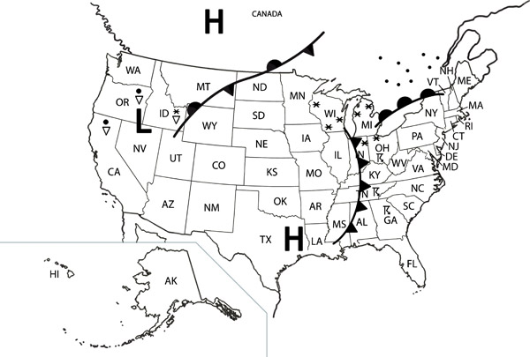
Take a look at the map to the right. Predict our weather over the next couple days. In your answer be sure to:
L
mT
- Identify and explain any weather structures (air masses, fronts, etc.)
cP
- Identify how our weather is going change in both temperature and moisture
- Identify why the weather patterns you are predicting and explaining are moving the way they are
Systems Writing Rubric
4 Points | 3 Points | 2 Points | 1 Point | 0 Point
Shows mastery of what an Earth system is; Identifies a specific example of an Earth system related to given topic and; Identifies and thoroughly explains specific interactions that occur both in the system and out of the system | Shows mastery of what an Earth system is; Identifies a specific example of an Earth system related to given topic and; Identifies and explains specific interactions that occur both in the system and out of the system; | Shows some mastery of what an Earth system is; Identifies a specific example of an Earth system related to given topic and; Identifies specific interactions that occur both in the system and out of the system; | Shows some mastery of what an Earth system is; Identifies a specific example of an Earth system related to given topic and; Partially identifies specific interactions that occur both in the system and out of the system; | Shows no mastery of what an Earth system is; Unable to or struggles to identify a specific example of an Earth system related to given topic and; Unable to or struggles to identify specific interactions that occur both in the system and out of the system;

